Table of Contents

Appendix A – Bridge 041 Performance Evaluation and Load Rating Analysis A-1

Experimental Evaluation Summary A-2

Load Rating Analysis Summary A-3

Appendix A-1 – Bridge Description A-4

Appendix A-2 – Experimental Evaluation A-5

Description of Test Equipment - THMPR™ System A-5

Instrumentation A-6

Test Execution A-7

Data Quality A-7

Modal Parameter Identification A-8

Appendix A-3 – Model Updating A-12

Appendix A-4 – Updated Model Ratings A-18

Span 1 A-18

Span 2 A-20

Appendix B – Bridge 063 Performance Evaluation and Load Rating Analysis B-1

Experimental Evaluation Summary B-2

Load Rating Analysis Summary B-3

Appendix B-1 – Bridge Description B-4

Appendix B-2 – Bridge 063 Experimental Evaluation B-5

Description of Test Equipment - THMPR™ System B-5

Instrumentation B-6

Test Execution B-7

Data Quality B-7

Modal Parameter Identification B-8

Appendix B-3 – Model Updating B-12

Appendix B-4 – Bridge 063 Updated Model Ratings B-14

Span 1 B-14

Span 2 B-16

Span 3 B-18

Appendix C – Bridge 076 Performance Evaluation and Load Rating Analysis C-1

Experimental Evaluation Summary C-2

Load Rating Analysis Summary C-3

Appendix C-1 – Bridge Description C-4

Appendix C-2 – Experimental Evaluation C-5

Description of Test Equipment - THMPR™ System C-5

Instrumentation C-6

Test Execution C-7

Data Quality C-7

Modal Parameter Identification C-8

Appendix D – Bridge 138 Performance Evaluation and Load Rating Analysis D-1

Appendix D-1 Bridge Description D-3

Appendix D-2 Experimental Evaluation D-5

Instrumentation D-6

Test Execution D-7

Data Quality D-8

Modal Parameter Identification D-9

Appendix D-3 - Finite Element (FE) Model Development and Rating D-12

FE Model Creation D-12

Error Screening for *A Priori* Model D-15

*A Priori* FE Model Rating D-17

Unknown Parameter Selection D-17

Initial Natural Frequency Analysis Comparison D-18

*A Priori* FE Model Load Rating D-21

Appendix D-4 - Model Experiment Correlation and Updated Model Rating D-23

Initial Values D-23

Updating Process D-24

Final Values D-25

Updated Model Fitness D-25

Rating D-30

Appendix E – Bridge 200 Performance Evaluation and Load Rating Analysis E-1

Experimental Evaluation Summary E-2

Load Rating Analysis Summary E-3

Appendix E-1 – Bridge Description E-4

Appendix E-2 – Experimental Evaluation E-5

Description of Test Equipment - THMPR™ System E-5

Instrumentation E-6

Test Execution E-7

Data Quality E-7

Modal Parameter Identification E-8

Appendix E-3 – Model Updating E-10

Appendix E-4 – Updated Model Ratings E-15

**PAGE INTENTIONALLY LEFT BLANK**

# Appendix A – Bridge 041 Performance Evaluation and Load Rating Analysis

**Northampton County Bridge 041**

|  |  |
| --- | --- |
| **BMS No:** | 48 7208 0684 9041 |
| **Feature Carried:** | Little Creek Road |
| **Feature Intersected:** | Little Martins Creek |
| **Structure Type:** | Two Span, Simply Supported Concrete Encased Steel I-Beam |
|  |  |
| **Test Date:** | 11/05/2014 |
| **Test Type:** | Dynamic Test |
| **Analysis and Rating Method:** | AASHTO ASR, LFR, and LRFR |

Table A.1. *A Priori* and Final Calibrated Model Rating Factors for Bridge 041.

|  |  |  |  |  |
| --- | --- | --- | --- | --- |
| **Bridge 041** | Span 1 | | Span 2 | |
| Inventory | Operating | Inventory | Operating |
| A-Priori | | | | |
| Strength I LRFR* | 3.42 | 4.44 | 3.42 | 4.44 |
| Service II LRFR* | 2.72 | 3.54 | 2.72 | 3.54 |
| Strength I LFR+ | 4.07 | 6.79 | 4.07 | 6.79 |
| Strength I ASR+ | 1.51 | 3.09 | 1.51 | 3.09 |
| Updated Composite | | | | |
| Strength I LRFR* | 3.28 | 4.25 | 3.74 | 4.85 |
| Service II LRFR* | 2.59 | 3.37 | 3.02 | 3.92 |
| Strength I LFR+ | 3.43 | 5.73 | 3.96 | 6.62 |
| Strength I ASR+ | 1.41 | 2.92 | 1.64 | 3.38 |
| Updated Non-Composite | | | | |
| Strength I LRFR* | 2.62 | 3.40 | 2.77 | 3.58 |

* Used HL-93 load specification

+ Used HS-20 + Alternate Military load specification

Design drawings for this bridge were not available at the time of testing; however, STV Inc. produced a Load Rating Summary performed in 2012 that detailed the structure’s cross section. The geometry of the bridge and its components was verified via field measurements on the day of the test and is summarized in section 4 of this appendix. The structure was evaluated using forced vibration testing methods and the dynamic properties (natural frequencies and mode shapes) were extracted for finite element model calibration. An initial FE model was created based on site surveys and documentation received from STV Inc. This model was calibrated using the experimental data, evaluated for similitude to experimental results, and used to develop AASHTO load ratings for Strength I and Service II limit states. Controlling ratings for the initial and calibrated models are summarized in the above table. Distribution factors are provided in section 6 of this appendix.

## Experimental Evaluation Summary

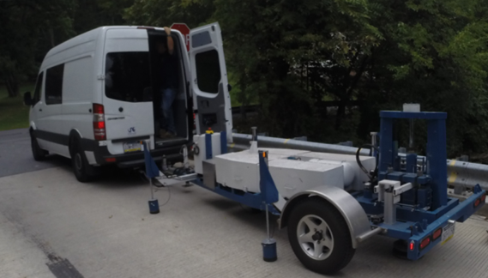The structure was evaluated on November 5, 2014 using forced vibration testing methods and the dynamic properties (natural frequencies and mode shapes) were extracted for finite element model calibration.

Figure 1. THMPR™ System

A self-contained modal impact trailer equipped with a falling mass impact system and local sensor array was used to execute the vibration tests. The superstructure was excited via a 25 kip impulse force at multiple, spatially distributed locations which resulted in up to 3 g’s of bridge deck acceleration. Acceleration responses were measured via a local sensor array of six accelerometers and multiple spatially distributed stationary global references secured to the bridge deck via glue adhesive prior to testing. Local modal parameter estimation was performed utilizing the Complex Mode Indicator Function (CMIF, described in detail below) and integrated into a final global modal parameter set. Six natural frequencies and mode shapes were identified for span 1 and five natural frequencies and mode shapes were identified for span 2 in the frequency band of 0-65 Hz (Figure 2 & Table 2).

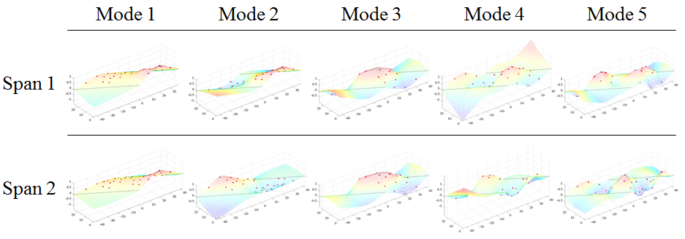

Figure 2. THMPR™™ Results – Overview of Global Mode Shapes

Table 2. THMPR™™ Results – Identified Natural Frequencies

|  |  |  |
| --- | --- | --- |
| **Mode** | **Span 1**  **Frequency [Hz]** | **Span 2**  **Frequency [Hz]** |
| 1 | 21.29 | 21.39 |
| 2 | 23.05 | 23.93 |
| 3 | 27.93 | 29.3 |
| 4 | 35.94 | 37.3 |
| 5 | 48.73 | 48.24 |
| 6 | 61.33 | - |

## Load Rating Analysis Summary

Strand7 FE Modelling Software was used in conjunction with computational software to perform a live load rating analysis for both spans of the bridge. An initial finite element (FE) model was created in Strand7 for all three spans. Conservative boundary conditions – a pin/roller configuration – were applied to the model. Continuity conditions reflecting initial engineering judgment and agreement with STV Inc.’s assessment of likely composite behavior were applied between FE elements representing the steel girders and concrete deck slab. Material properties consistent with AASHTO *MBE* guidelines were applied to members.

The structure was modeled using finite element analysis and computational software. An initial finite element (FE) model was created in Strand7 using the RAMPS software package developed at Drexel University as part of a National Institute of Standards and Technology Innovation Program (NIST-TIP) and the National Cooperative Highway Research Program Project 12-103 (NCHRP 12-103). The 3D geometric model – also known as an eccentric beam model - (Figure 3) utilizes beam elements for the steel I-section and concrete encasement. Shell elements are used to model the deck and concrete curb. Rigid links as well as beam elements with variable stiffness are used to enforce compatibility of the displacements between the various structural elements. The average mesh size – or average element length/width - for the model is about 1.5 feet. This distance is less than half the minimum distance between any sensor pair on the THMPR™ system. The FE model was error screened for total mass by comparing vertical support reactions to those estimated using hand calculations with a single line girder model; the difference between the sum of reactions for all 16 supports and 16 times the single support vertical reaction from single line girder estimation was less than 0.1%.

Y

X

Z

|  |  |
| --- | --- |
|  |  |

Figure 3. Left - *A Priori* FE Model of single span of Bridge 041. Right – Schematic of Eccentric Beam Model

The initial model was rated for AASHTO ASR, LFR, and LRFR Strength I and Service II limit states. It was then calibrated to the natural frequencies and mode shapes developed through experimentation. This calibration process adjusted unknown model characteristics to that the FE model natural frequencies and mode shapes had values closer to those found via experimentation. The model characteristics - or parameters – chosen for the calibration process effect global stiffness (in the case of deck stiffness, for example) or local stiffness (in the case of boundary conditions). It should be noted that these parameter values do not reflect the *actual*  intrinsic properties of strength or rotation resistance but are instead rational surrogates for load carrying and vibrational phenomena. Six calibrated models with strong agreement to the experimental data were accepted as being a likely model. All six of these models shared similar values for calibrated parameters (such as material strength, continuity, and boundary conditions); because of the negligible difference between calibrated models a single calibrated model was chosen from the group for load rating. In order to assure the most conservative load rating estimate while utilizing an updated FE model, stiffness and strength contributions from the concrete encasement, barriers, and boundary conditions were ignored in the ratings for the updated models.

## Appendix A-1 – Bridge Description

Northampton County Bridge 041 is a two span, simply supported, concrete encased steel I-Beam structure with a 60⁰ skew to the centerline of the bridge (40⁰ skew in PennDOT classification). The bridge carries Little Creek Road over Little Martin’s Creek has an ADT of 200 and has a current posted weight limit of 20 tons. With a sufficiency rating of 46.0, the bridge is evaluated as “Not Deficient.” Both spans were measured as 41’-6” span length and a roadway width of 22’-6”. Each span carries Type-2 strong post guide rails over a curb measuring 6.5”x14” on either side of the roadway (Figure 4). The overall deck thickness was estimated to be approximately 16” with a 2.75” overlay, implying the deck is 13.25”. Each span has six (8) concrete encased steel I-beams spaced at 3’-3” with overall dimensions of 22”x12”. Each girder has what appears to be 1-2” of shotcrete applied to the surface of the original concrete encasement at a time unknown to the engineer. Cracking of the shotcrete was more apparent in this structure than in others tested. The presence of shotcrete over the original concrete encasement may imply that some deterioration of the encasement was present.

No original plans exist for the bridge; however STV Inc. produced a Load Rating Summary performed in 2012 that details the structure cross-section. In their load rating, STV noted that Northampton County produced approximate beam dimensions after taking cores of the structure. Measurements taken in the field agreed with those reported by STV Inc.

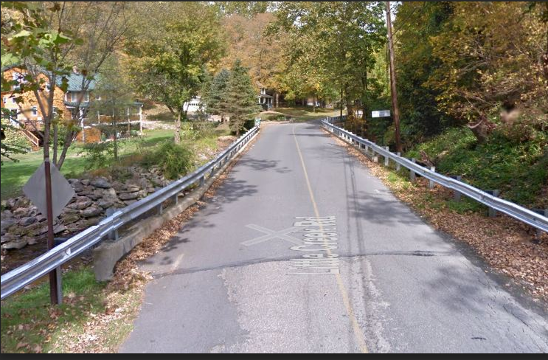

Figure 4. Northampton County Bridge 041

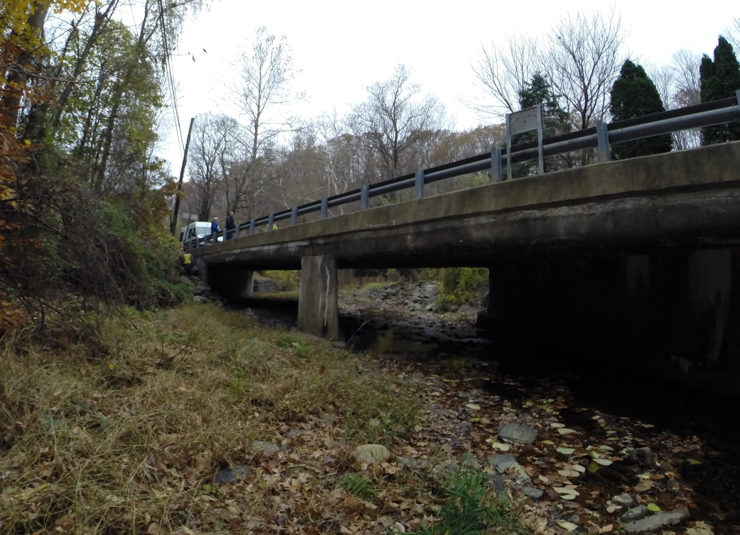

Figure 5. Elevation view of Northampton County Bridge 041

## Appendix A-2 – Experimental Evaluation

Northampton County Bridge 041 was evaluated using vibration testing methods. The bridge was dynamically excited at several locations on the deck surface using a broad band impact force, and its corresponding vibration responses were measured using accelerometers that were also located on the deck. The combined input-output vibration measurements were subsequently analyzed to extract the dynamic properties of the structure which were then used to calibrate a finite element model of the bridge. Details of the experimental setup, the test execution and the data analysis methods employed for the bridge are provided in the following sections.

### Description of Test Equipment - THMPR™ System

The Targeted Hits to Measure Performance Responses (THMPR™) system is a self-contained rapid modal testing trailer and streamlined data processing software which extracts modal parameters, such as frequencies and mode shapes, of a structure. The extracted modal parameters may then be used to determine anomalous behavior as well as provide experimental data for finite element model calibration. The system, shown in Figure 6, is comprised of a physical test device which utilizes a significantly reconfigured Falling Weight Deflectometer trailer with modifications to (1) provide a single, large (~30 kip) broadband impact source, and (2) collect the resulting free-decay response of the bridge’s surface in a spatially distributed manner (and in-turn be able to capture local mode shapes). The local sensor array is shown in Figure 7. The trailer is towed along the bridge deck and single-input-multiple-output (SIMO) impact testing is performed at targeted locations. The data is wirelessly acquired at each location and passed to semi-automated modal processing software which performs (1) data quality checks, (2) frequency response function development and (3) modal parameter estimation. The local mode shapes are then linearly combined into a final global modal parameter set utilizing selected stationary references previously secured along an available sidewalk and cabled to an independent, GPS synchronized data acquisition.

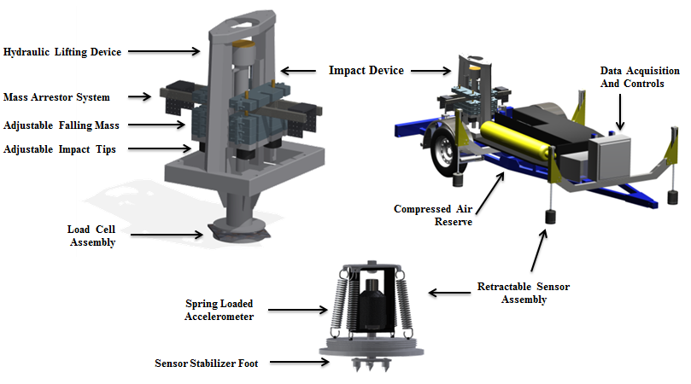

Figure 6. THMPR™ System - Primary Components

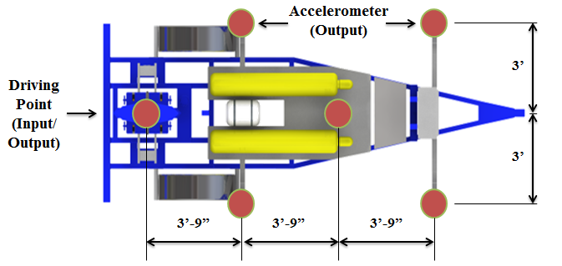

Figure 7. THMPR™ Local Sensor Array

### Instrumentation

The typical instrumentation plan for a single span is shown in Figure 8. A total of six stationary reference accelerometers were used for each of the two spans. The references were temporarily attached to the bridge deck using glue adhesive at the quarter span, mid span, and three-quarter span locations along each lane. The reference accelerometers remained at the same locations on the deck throughout the vibration testing and were used to link together the vibrations measured by THMPR™’s local sensor array of six accelerometers (Figure 7). The reference accelerometers were cabled to GPS synchronized data acquisition systems along each shoulder and out of the way of traffic.

A total of six impact locations were selected for the test: (1) at quarter span in the right lane, (2) at mid span in the right lane, (3) at three-quarter span in the right lane, (4) at quarter span in the left lane, (5) at mid span in the left lane, and (6) at three-quarter span in the left lane. The impact locations were chosen so that the measured vibration responses would have a dense spatial resolution and to vary the spatial characteristics of the input excitation. The former consideration is important for resolving different mode shapes from the vibration measurements, while the latter is important for exciting different vibration modes. Note, only three of the six local output sensors were required for data analysis.

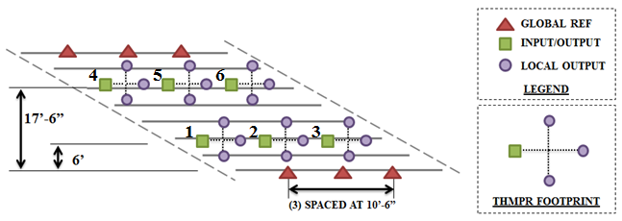

Figure 8. Typical Instrumentation Plan

### Test Execution

THMPR™ system testing was conducted on November 5, 2014. THMPR™’s impact head was centered above a selected impact location on the deck and the GPS synchronized accelerometer array attached to THMPR™ was remotely deployed. This lowered the six accelerometer housings onto the bridge deck and compressed them against the surface (Figure 9). The impact force and bridge vibration measurements were recorded at a rate of 3,200 samples per second (Hz) for each span in order to precisely define the shape of the impulse signal and for a duration of 10 seconds to ensure the complete capture of the structure’s post-impact free vibration decay response. A total of three separate impacts were recorded for averaging and noise reduction purposes at each of the six locations for each of the three spans.

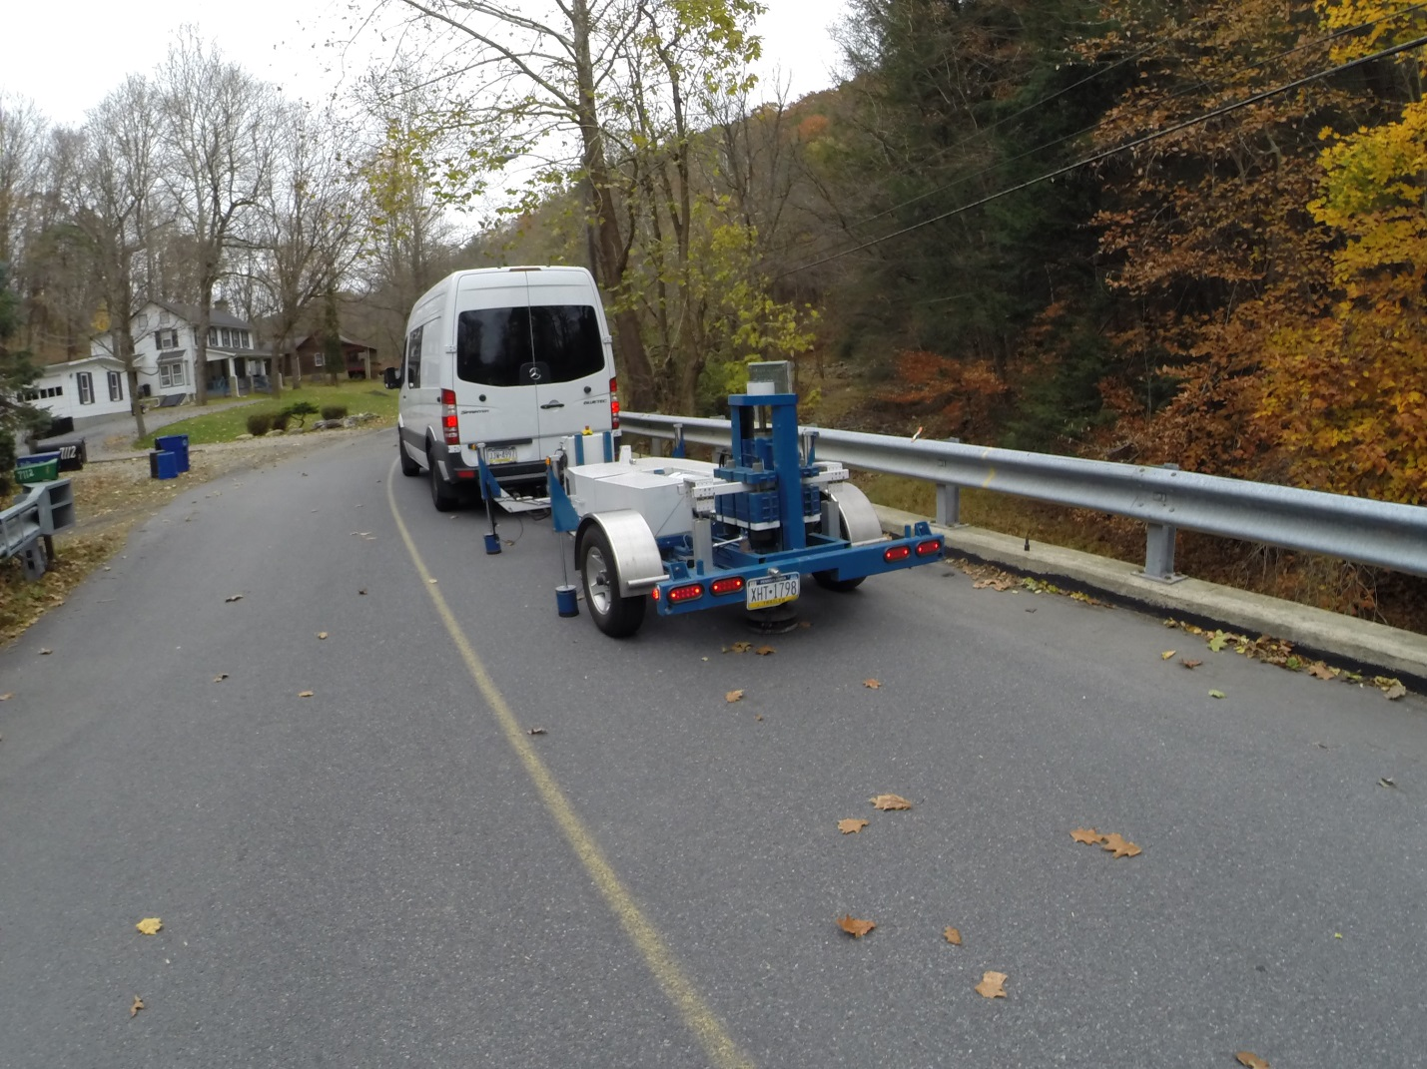

SENSOR HOUSING

Figure 9. THMPR™ System Test Execution

### Data Quality

Typical impact forces of up to 25,000 lbs. were observed (Figure 10A) with an approximate usable frequency range of 0-65 Hz (Figure 10B). The impact forces produced by THMPR™ also resulted in bridge acceleration magnitudes of up to 3 g’s (Figure 11A). Frequency content of the structural response (Figure 11B) shows clearly defined, smooth peaks of resonance which indicates linearity, adequate frequency resolution, and good excitation of all fundamental modes of interest. The relatively large structural response and the acquisition of ten second time windows provided a frequency resolution of 0.09 Hz which resulted in good characterization of closely spaced modes.

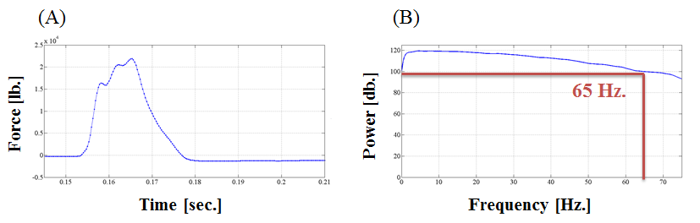

Figure 10. (A) Typical Force Time History & (B) Typical Force Frequency Content

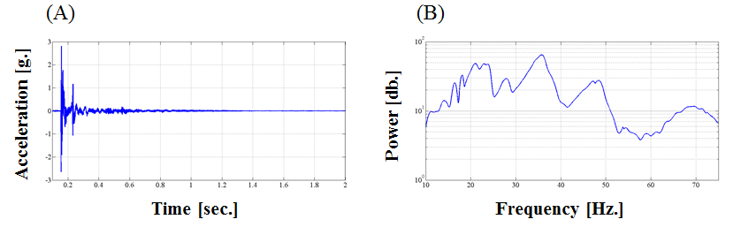

Figure 11. (A) Typical Response Time History & (B) Typical Response Frequency Content

### Modal Parameter Identification

The modal parameters for the structure were identified from the vibration measurements onsite after completion of the testing to provide immediate feedback on the data quality, structural response of the bridge, and operating condition of the test equipment to the on-site engineers. The modal parameters include the natural frequencies and the modal vectors (mode shapes) for each mode. These parameters are directly related to the in-situ mass and stiffness characteristics of the bridge, and are used for calibrating the FE model of the structure.

The modal parameter identification process starts with the computation of frequency response functions for each input-output measurement pair. A frequency response function is essentially the frequency domain transform of measured acceleration response at each sensor location divided by the measured impact force for each test location. The Complex Mode Indicator Function (CMIF) was then calculated for each test location (Figure 12 and Figure 13) using the frequency response functions created in the previous step. The CMIF is computed by singular value decomposition of the matrix of frequency response functions for each test location. The largest singular values are plotted against frequency to create the CMIF plot. Each peak in the CMIF plot represents a possible mode of vibration for the structure and the amplitude of the singular value is directly related to the dominance of the corresponding modal vector at that test location. The singular values for each independent impact location are super imposed to compare areas of resonance and ultimately select global modal parameters. Additionally, in regions of high modal density, modal vectors associated with large singular values were plotted spatially and compared in order to determine the appropriate selection of the dominant global mode in that region. A total of six global vibration modes (global poles) for span 1 and five global vibration modes for span 2 were identified from the CMIF plots as shown in Figure 12 and Figure 13.

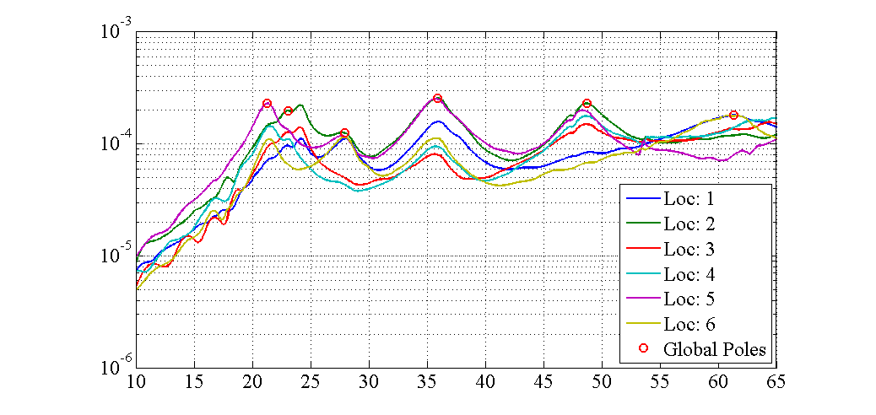

Figure 12. Span 1 – Complex Mode Indicator Function (CMIF)

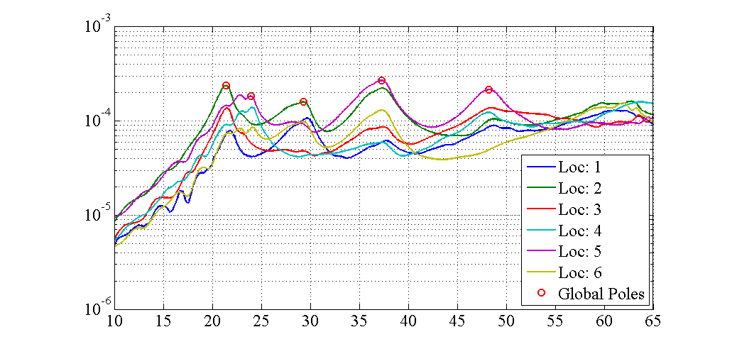

Figure 13. Span 2 – Complex Mode Indicator Function (CMIF)

For each of the spans, local mode shapes for each impact location were extracted at each global pole and combined into a global parameter set. Master mode shapes were selected for each mode based on the relative amplitude of the CMIF singular value for each impact location. The impact location associated with the largest CMIF amplitude for a specific vibration mode contains the highest signal to noise ratio and the corresponding mode shape was designated the master shape for that vibration mode. For each global pole, the modal amplitudes of the stationary references were compared between the local master mode shape and the remaining local mode shapes. A scaling coefficient was developed via a least squares approximation and used to linearly integrate the independent local mode shapes into the local master mode shape and form a global parameter set. Local mode shapes extracted from impact locations which coincided with a point of zero displacement (nodal point) for a particular mode were discarded and not included within the global modal parameter set. Additionally, a combination of the stationary references for each master local mode shape was chosen on an individual mode basis to avoid using reference sensors in locations of low modal amplitude for a particular mode. Span 1 global mode shapes and frequencies are shown in Figure 14 and Table 4, respectively. Span 2 global mode shapes and frequencies are shown in Figure 15 and Table 5, respectively. It should be noted that the interstitial areas between the discrete experimental degrees-of-freedom for the mode shapes were interpolated using a fourth order equation to aid in the visualization of these shapes. Additionally, the dashed lines represent the extents of the bridge, and the mode shape contours beyond these extents should be neglected.

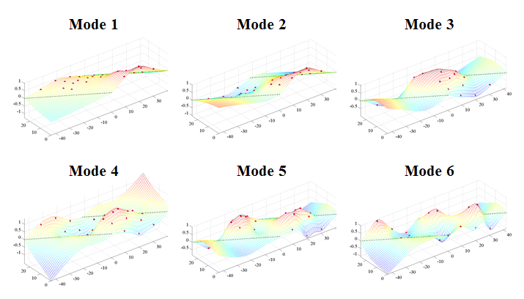

Figure 14. Span 1 – THMPR™ Results - Global Mode Shapes

Table 4. Span 1 – THMPR™ Results – Identified Natural Frequencies

|  |  |  |  |
| --- | --- | --- | --- |
| **Mode** | **Frequency [Hz]** | **Master**  **Location** | **Included Locations** |
| 1 | 21.29 | 2 | 2 3 4 5 6 |
| 2 | 23.05 | 2 | 1 2 3 4 5 |
| 3 | 27.93 | 2 | 1 2 5 6 |
| 4 | 35.94 | 2 | 1 2 3 4 5 6 |
| 5 | 48.73 | 2 | 2 3 4 5 |
| 6 | 61.33 | 1 | 1 3 4 6 |

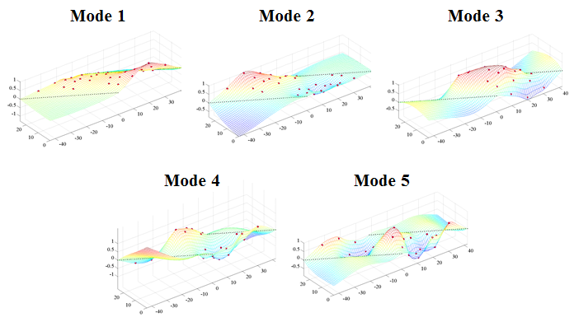

Figure 15. Span 2 – THMPR™ Results – Global Mode Shapes

Table 5. Span 2 – THMPR™ Results – Identified Natural Frequencies

|  |  |  |  |
| --- | --- | --- | --- |
| **Mode** | **Frequency [Hz]** | **Master**  **Location** | **Included Locations** |
| 1 | 21.39 | 2 | 1 2 3 4 5 6 |
| 2 | 23.93 | 5 | 1 2 3 4 5 6 |
| 3 | 29.3 | 2 | 1 2 3 5 6 |
| 4 | 37.3 | 5 | 1 2 3 5 6 |
| 5 | 48.24 | 5 | 1 2 3 4 5 |

## Appendix A-3 – Model Updating

The *a priori* model was updated for each span using a multi-start method with 6 updating trials starting from different combinations of initial parameter values. The updating process iteratively adjusts model parameters to enforce stronger agreement between FE model behavior and experimental data. All parameters are global across the entire model. The deck and encasement stiffness parameters were updated by adjusting f’c/E of the concrete material used in the model. Composite action was updated by adjusting the stiffness of the composite action links. Rotational stiffness (R2) about the transverse axis normal to the girder lines represents the degree of partial fixity of the bearings. Parameters were given an initial value of either the upper or lower bound of possible calibration values, as shown in Table 6.

Table 6. Model Calibration Starting Points for Six Model Calibration Trials

|  |  |  |  |  |
| --- | --- | --- | --- | --- |
|  | **Start Point** | | | |
| **Update** | *Deck* | *Encasement* | *Composite Action* | *R2* |
| *1* | Min | Min | Min | Min |
| *2* | Max | Min | Min | Min |
| *3* | Min | Max | Min | Min |
| *4* | Min | Min | Max | Min |
| *5* | Min | Min | Min | Max |
| *6* | Max | Max | Max | Max |

All six calibrated models for each span had negligible differences in the final updated parameters as well as negligible differences between FE model natural frequencies and mode shapes accuracy when compared to the experiment. One model was chosen for each span for rating purposes. Updated model modes shapes are typical for both spans of the structure and are illustrated in Table 7 with the corresponding experimental model shape. FE model frequencies for both spans and all calibrated and *a priori* models are presented in tables 8 through 20. The *a priori* model from each span exhibited natural frequencies lower than that of the actual structure, indicating a lack of global stiffness. All updated models for both spans showed negligible differences in frequency from the experiment (+/- 5%). Frequency differences between model and experiment were used for parameter estimation while mode shapes were used for model/experiment frequency pairing. Despite neglecting mode shapes for updating purposes, the updated models showed similar or better agreement with the experimental mode shapes than the *a priori* models. The updating results indicate that the updated models are accurate indicators of global stiffness.

Table 7. Typical Mode Shapes

|  |  |  |  |
| --- | --- | --- | --- |
| A-Priori Shapes | Mode Number | Typical Updated Model Shaped | Mode Number |
|  | **1** |  | **1** |
|  | **2** |  | **2** |
|  | **3** |  | **3** |
|  | **5** |  | **4** |
|  | **8** |  | **5** |
|  | **9** |  | **9** |

Table 8. Comparison of *A Priori* and Experimental Mode Frequencies for Span 1

|  |  |  |  |  |
| --- | --- | --- | --- | --- |
| **MAC** | **Natural Frequency** | | | **Analytical Mode** |
| *Experimental [Hz]* | *Analytical [Hz]* | *% Difference* |
| 0.8813 | 21.2891 | 11.7443 | -44.834 | 1 |
| 0.8523 | 23.0469 | 12.5899 | -45.3728 | 2 |
| 0.9445 | 27.9297 | 19.0544 | -31.7771 | 3 |
| 0.8658 | 35.9375 | 26.4372 | -26.4355 | 5 |
| 0.4339 | 48.7305 | 40.0885 | -17.7343 | 8 |
| 0.6477 | 61.3281 | 44.7317 | -27.0617 | 9 |

Table 9. Comparison of Update 1 and Experimental Mode Frequencies for Span 1

|  |  |  |  |  |
| --- | --- | --- | --- | --- |
| **MAC** | **Natural Frequency** | | | **Analytical Mode** |
| *Experimental [Hz]* | *Analytical [Hz]* | *% Difference* |
| 0.9552 | 21.2891 | 21.7215 | 2.0311 | 1 |
| 0.7458 | 23.0469 | 22.4636 | -2.5307 | 2 |
| 0.9539 | 27.9297 | 27.5927 | -1.2067 | 3 |
| 0.9636 | 35.9375 | 36.4214 | 1.3466 | 4 |
| 0.8747 | 48.7305 | 48.1366 | -1.2188 | 5 |
| 0.729 | 61.3281 | 62.0981 | 1.2555 | 9 |

Table 10. Comparison of Update 2 and Experimental Mode Frequencies for Span 1

|  |  |  |  |  |
| --- | --- | --- | --- | --- |
| **MAC** | **Natural Frequency** | | | **Analytical Mode** |
| *Experimental [Hz]* | *Analytical [Hz]* | *% Difference* |
| 0.9555 | 21.2891 | 21.708 | 1.968 | 1 |
| 0.7454 | 23.0469 | 22.4102 | -2.7625 | 2 |
| 0.9557 | 27.9297 | 27.5516 | -1.3538 | 3 |
| 0.9641 | 35.9375 | 36.3906 | 1.2608 | 4 |
| 0.8735 | 48.7305 | 48.0751 | -1.3449 | 5 |
| 0.7325 | 61.3281 | 61.9579 | 1.0269 | 9 |

Table 11. Comparison of Update 3 and Experimental Mode Frequencies for Span 1

|  |  |  |  |  |
| --- | --- | --- | --- | --- |
| **MAC** | **Natural Frequency** | | | **Analytical Mode** |
| *Experimental [Hz]* | *Analytical [Hz]* | *% Difference* |
| 0.9425 | 21.2891 | 21.6746 | 1.8107 | 1 |
| 0.7733 | 23.0469 | 22.5021 | -2.3636 | 2 |
| 0.9494 | 27.9297 | 27.6417 | -1.031 | 3 |
| 0.9629 | 35.9375 | 36.3608 | 1.1779 | 4 |
| 0.8782 | 48.7305 | 48.038 | -1.421 | 5 |
| 0.7113 | 61.3281 | 62.2931 | 1.5735 | 9 |

Table 12. Comparison of Update 4 and Experimental Mode Frequencies for Span 1

|  |  |  |  |  |
| --- | --- | --- | --- | --- |
| **MAC** | **Natural Frequency** | | | **Analytical Mode** |
| *Experimental [Hz]* | *Analytical [Hz]* | *% Difference* |
| 0.9543 | 21.2891 | 21.7826 | 2.3182 | 1 |
| 0.7508 | 23.0469 | 22.4708 | -2.4997 | 2 |
| 0.9552 | 27.9297 | 27.5469 | -1.3707 | 3 |
| 0.9644 | 35.9375 | 36.4083 | 1.3099 | 4 |
| 0.8764 | 48.7305 | 48.1483 | -1.1947 | 5 |
| 0.7322 | 61.3281 | 61.9288 | 0.9795 | 9 |

Table 12. Comparison of Update 5 and Experimental Mode Frequencies for Span 1

|  |  |  |  |  |
| --- | --- | --- | --- | --- |
| **MAC** | **Natural Frequency** | | | **Analytical Mode** |
| *Experimental [Hz]* | *Analytical [Hz]* | *% Difference* |
| 0.8776 | 21.2891 | 21.5732 | 1.3346 | 1 |
| 0.8606 | 23.0469 | 22.2423 | -3.4912 | 2 |
| 0.956 | 27.9297 | 27.6003 | -1.1792 | 3 |
| 0.9681 | 35.9375 | 36.5244 | 1.633 | 4 |
| 0.8814 | 48.7305 | 48.2685 | -0.9479 | 5 |
| 0.7444 | 61.3281 | 62.4461 | 1.8229 | 9 |

Table 13. Comparison of Update 6 and Experimental Mode Frequencies for Span 1

|  |  |  |  |  |
| --- | --- | --- | --- | --- |
| **MAC** | **Natural Frequency** | | | **Analytical Mode** |
| *Experimental [Hz]* | *Analytical [Hz]* | *% Difference* |
| 0.8772 | 21.2891 | 21.5653 | 1.2976 | 1 |
| 0.861 | 23.0469 | 22.2363 | -3.517 | 2 |
| 0.956 | 27.9297 | 27.5998 | -1.1811 | 3 |
| 0.9681 | 35.9375 | 36.5303 | 1.6496 | 4 |
| 0.8811 | 48.7305 | 48.2769 | -0.9307 | 5 |
| 0.7446 | 61.3281 | 62.4529 | 1.834 | 9 |

Table 14. Comparison of *A Priori* Model and Experimental Modal Frequencies for Span 2

|  |  |  |  |  |
| --- | --- | --- | --- | --- |
| **MAC** | **Natural Frequency** | | | **Analytical Mode** |
| *Experimental [Hz]* | *Analytical [Hz]* | *% Difference* |
| 0.8387 | 21.3867 | 11.7443 | -45.0859 | 1 |
| 0.6801 | 23.9258 | 12.5899 | -47.3795 | 2 |
| 0.8319 | 29.2969 | 19.0544 | -34.9608 | 3 |
| 0.7513 | 37.3047 | 26.4372 | -29.1316 | 5 |
| 0.342 | 48.2422 | 40.0885 | -16.9017 | 8 |

Table 15. Comparison of Update 1 and Experimental Modal Frequencies for Span 2

|  |  |  |  |  |
| --- | --- | --- | --- | --- |
| **MAC** | **Natural Frequency** | | | **Analytical Mode** |
| *Experimental [Hz]* | *Analytical [Hz]* | *% Difference* |
| 0.9418 | 21.3867 | 21.7614 | 1.7522 | 1 |
| 0.7808 | 23.9258 | 22.9391 | -4.1238 | 2 |
| 0.8586 | 29.2969 | 28.4937 | -2.7415 | 3 |
| 0.8736 | 37.3047 | 37.6947 | 1.0456 | 4 |
| 0.5959 | 48.2422 | 49.7117 | 3.0461 | 5 |

Table 16. Comparison of Update 2 and Experimental Modal Frequencies for Span 2

|  |  |  |  |  |
| --- | --- | --- | --- | --- |
| **MAC** | **Natural Frequency** | | | **Analytical Mode** |
| *Experimental [Hz]* | *Analytical [Hz]* | *% Difference* |
| 0.9596 | 21.3867 | 22.1237 | 3.4462 | 1 |
| 0.8238 | 23.9258 | 22.8931 | -4.3162 | 2 |
| 0.8637 | 29.2969 | 28.4316 | -2.9536 | 3 |
| 0.8569 | 37.3047 | 37.5435 | 0.64 | 4 |
| 0.561 | 48.2422 | 49.341 | 2.2776 | 5 |

Table 17. Comparison of Update 3 and Experimental Modal Frequencies for Span 2

|  |  |  |  |  |
| --- | --- | --- | --- | --- |
| **MAC** | **Natural Frequency** | | | **Analytical Mode** |
| *Experimental [Hz]* | *Analytical [Hz]* | *% Difference* |
| 0.9453 | 21.3867 | 21.7853 | 1.8639 | 1 |
| 0.7865 | 23.9258 | 22.9246 | -4.1845 | 2 |
| 0.8585 | 29.2969 | 28.4815 | -2.7831 | 3 |
| 0.8715 | 37.3047 | 37.6912 | 1.0361 | 4 |
| 0.5921 | 48.2422 | 49.7106 | 3.0438 | 5 |

Table 18. Comparison of Update 4 and Experimental Modal Frequencies for Span 2

|  |  |  |  |  |
| --- | --- | --- | --- | --- |
| **MAC** | **Natural Frequency** | | | **Analytical Mode** |
| *Experimental [Hz]* | *Analytical [Hz]* | *% Difference* |
| 0.9597 | 21.3867 | 22.0482 | 3.093 | 1 |
| 0.8365 | 23.9258 | 22.9876 | -3.9214 | 2 |
| 0.849 | 29.2969 | 28.3102 | -3.368 | 3 |
| 0.8428 | 37.3047 | 37.5254 | 0.5916 | 4 |
| 0.5404 | 48.2422 | 49.617 | 2.8498 | 5 |

Table 19. Comparison of Update 5 and Experimental Modal Frequencies for Span 2

|  |  |  |  |  |
| --- | --- | --- | --- | --- |
| **MAC** | **Natural Frequency** | | | **Analytical Mode** |
| *Experimental [Hz]* | *Analytical [Hz]* | *% Difference* |
| 0.9606 | 21.3867 | 22.106 | 3.3633 | 1 |
| 0.8279 | 23.9258 | 22.8902 | -4.3283 | 2 |
| 0.8628 | 29.2969 | 28.4447 | -2.9088 | 3 |
| 0.8548 | 37.3047 | 37.5894 | 0.7631 | 4 |
| 0.5564 | 48.2422 | 49.4113 | 2.4234 | 5 |

Table 20. Comparison of Update 6 and Experimental Modal Frequencies for Span 2

|  |  |  |  |  |
| --- | --- | --- | --- | --- |
| **MAC** | **Natural Frequency** | | | **Analytical Mode** |
| *Experimental [Hz]* | *Analytical [Hz]* | *% Difference* |
| 0.9591 | 21.3867 | 22.0786 | 3.235 | 1 |
| 0.8369 | 23.9258 | 22.8976 | -4.2975 | 2 |
| 0.8591 | 29.2969 | 28.4262 | -2.972 | 3 |
| 0.8466 | 37.3047 | 37.609 | 0.8156 | 4 |
| 0.5409 | 48.2422 | 49.48 | 2.5658 | 5 |

## Appendix A-4 – Bridge Geometry and Material Properties

Table 21. Bridge Parameters Used in FE Model Construction and Rating

|  |  |  |  |
| --- | --- | --- | --- |
|  | Int/Ext | Notes |  |
| **Material Properties** | |  |  |
| Steel Fy (psi) | 30000 | Per AASHTO suggestion |  |
| Concrete f'c (psi) | 2500 | Per AASHTO suggestion |  |
| Concrete Modulus (psi) | 2850000 |  |  |
| Weight of Concrete (lb/ ft3) | 150 |  |  |
| Weight of Steel (lb/ft3) | 490 |  |  |
| **Beam Cross Section** | |  |  |
| Deck Offset* (in.) | -7.75 |  |  |
| Deck thickness (in.) | 13.25 |  |  |
| Effective width (in.) | 40.2/29.4 |  |  |
| Flange thickness (in.) | 0.7075 |  |  |
| Flange width (in.) | 9 |  |  |
| Web thickness (in.) | 0.5204 |  |  |
| Web depth (in.) | 25.585 |  |  |
| Encasement width (in.) | 15 |  |  |
| Encasement depth (in.) | 22 |  |  |
| Distance from Top of Slab to PNA (in.) | 5.9983 |  |  |
| Girder Moment of Inertia (in4) | 2927.7 |  |  |
| Composite Yield Moment | 7597300 | / 7431806.512 |  |
| Composite Plastic Moment Capacity | 11764428.35 | / 11335227.61 |  |
|  |  |  |  |
| **Bridge Cross Section** | |  |  |
| Wearing Surface | 2.75 |  |  |
| Out-to-Out Width (in.) | 300 |  |  |
| Road Width (in.) | 270 |  |  |
| Barrier Height (in.) | 0 |  |  |
| Barrier width(in.) | 0 |  |  |
| Curb Height (in.) | 7 |  |  |
| Girder Spacing (in.) | 40.2 |  |  |
| Number of Girders | 8 |  |  |
| Number of Lanes | 2 |  |  |
|  |  |  |  |
| * Distance from top of flange to bottom of deck (values<0 indicate flange embedded in deck) | | | |

## Appendix A-5 – LRFR Rating Details

The dead load demands are computed with the FE model by running a static solver with self-weight turned on. The first dead load case includes the weight of the deck and the structure beneath the deck, but with the stiffness of the deck turned off, as it has no capacity when poured. The superimposed dead load case is run with the stiffness of the deck turned back on and the weight of the deck and structure excluded. The demands from the wearing surface are computed in a separate load case without altering the stiffness of any of the elements. The load from the wearing surface is modelled as point masses equivalent to the uniform load caused by the wearing surface.

Point loads corresponding to AASHTO HL-93 design truck (including tandem) along with lane load are positioned on the model to produce maximum response. Several locations and different lanes are loaded. The resulting forces in all girders from each load case are recorded at midspan as this location is where maximum response is achieved.

The total composite bending moment is computed using the following equation:

$$M_{c}=M+F_{A}*D$$

Where “M” is the bending moment about the girders’ principle axes, “FA” is the axial force in the beam element and “D” is the distance from the centroid of the girder to the centroid of the deck. The axial force in the beam element is recorded in lieu of axial force in the deck for ease of response retrieval and is permitted since any axial force in the beam element is due to the transfer from the deck via the rigid links.

The forces in the beam elements are also used to compute stress in the bottom flange using the principle of mechanics of materials and the girder section properties.

The responses are combined, multi presence and impact factors applied, and results compared, creating an envelope of the highest possible demands.

The capacity of the girder is computed following the procedures and requirements set forth in the AASHTO Manual for Bridge Evaluation. In cases where the bridge is being rated under the non-composite condition, the capacity may be the plastic moment capacity of the girder, in which case there are no plastic forces contributed by the deck in the calculation.

The rating factors are computed using the following equation:

$$RF=\frac{∅*R-∅*DL-∅*DLW}{∅*LL}$$

Where “R” is the capacity of the girder section, “DL” is the dead load demands, “DLW” is the demands from the wearing surface, and “LL” is the live load demands. The load and resistance factors ($∅$) are set as prescribed by the AASHTO Manual for Bridge Evaluation.

The following tables present the rating factors, demands and capacities for every girder for the updated models that had the lowest ratings and with composite action present.

Table 22: Span 1 Updated Composite LRFR Rating Factors

|  |  |  |  |  |  |  |  |  |
| --- | --- | --- | --- | --- | --- | --- | --- | --- |
| Girder # | 1 | 2 | 3 | 4 | 5 | 6 | 7 | 8 |
| **Limit State: Strength 1 Load Rating Factors** | | | | | | | | |
| Inv. | 3.74 | 3.81 | 4.89 | 5.48 | 4.99 | 4.95 | 3.57 | 3.28 |
| Op. | 4.85 | 4.94 | 6.34 | 7.10 | 6.47 | 6.41 | 4.63 | 4.25 |
| **Limit State: Service 2 Load Rating Factors** | | | | | | | | |
| Inv. | 2.92 | 2.64 | 3.74 | 4.15 | 3.85 | 3.80 | 2.60 | 2.65 |
| Op. | 3.80 | 3.44 | 4.86 | 5.40 | 5.01 | 4.95 | 3.38 | 3.45 |

Table 23: Span 1 Updated Composite LRFR Demands

|  |  |  |  |  |  |  |  |  |
| --- | --- | --- | --- | --- | --- | --- | --- | --- |
| Girder # | 1 | 2 | 3 | 4 | 5 | 6 | 7 | 8 |
| **Moment Demands (lb-in)** | | | | | | | | |
| DL | 1302316 | 1698940 | 1700202 | 1698631 | 1698373 | 1699733 | 1644469 | 1359322 |
| SDL | 646991.7 | 534398.4 | 379399.4 | 349838.3 | 349110.2 | 372727.8 | 529651.3 | 652887.8 |
| DLW | 114262.4 | 104687.3 | 90735.31 | 91223.83 | 91348.01 | 90483.43 | 104878.3 | 116098.7 |
| LL | 1217173 | 1218416 | 973828.8 | 872936.3 | 958294.8 | 963325.3 | 1312102 | 1374813 |
| **Stress Demands (psi)** | | | | | | | | |
| DL | 6642.11 | 8323.84 | 7881.48 | 7836.91 | 7843.58 | 7902.95 | 7647.73 | 6575.83 |
| SDL | 2617.28 | 2144.69 | 1491.05 | 1359.21 | 1355.35 | 1483.28 | 2146.08 | 2639.93 |
| DLW | 462.08 | 418.8 | 355.62 | 355.75 | 356.41 | 358.08 | 422.89 | 469.81 |
| LL | 4939 | 5126.6 | 3861.1 | 3510.1 | 3784.5 | 3792.6 | 5415.7 | 5451.8 |

Table 24: Span 1 Updated Composite LRFR Capacity

|  |  |
| --- | --- |
| Yield Stress Limit for Service State Capacity (psi): | 30000 |
| **Strength 1 Capacity of Exterior Girders** | |
| Stress Limit for Positive Moment Region (psi): | 30000 |
| Moment Limit for Positive Moment Region (lb-in): | 10582898 |
| **Strength 1 Capacity of Interior Girders** | |
| Stress Limit for Positive Moment Region (psi): | 30000 |
| Moment Limit for Positive Moment Region (lb-in): | 11068044 |

Table 25: Span 2 Updated Composite LRFR Rating Factors

|  |  |  |  |  |  |  |  |  |
| --- | --- | --- | --- | --- | --- | --- | --- | --- |
| Girder # | 1 | 2 | 3 | 4 | 5 | 6 | 7 | 8 |
| **Limit State: Strength 1 Load Rating Factors** | | | | | | | | |
| Inv. | 4.05 | 4.25 | 5.38 | 6.36 | 5.75 | 5.71 | 4.12 | 3.75 |
| Op. | 5.26 | 5.51 | 6.97 | 8.25 | 7.45 | 7.40 | 5.34 | 4.86 |
| **Limit State: Service 2 Load Rating Factors** | | | | | | | | |
| Inv. | 3.28 | 3.02 | 4.18 | 4.84 | 4.46 | 4.42 | 3.07 | 3.11 |
| Op. | 4.27 | 3.93 | 5.43 | 6.29 | 5.79 | 5.74 | 3.99 | 4.05 |

Table 26: Span 2 Updated Composite LRFR Demands

|  |  |  |  |  |  |  |  |  |
| --- | --- | --- | --- | --- | --- | --- | --- | --- |
| Girder # | 1 | 2 | 3 | 4 | 5 | 6 | 7 | 8 |
| **Moment Demands (lb-in)** | | | | | | | | |
| DL | 1302296 | 1698909 | 1700193 | 1698618 | 1698358 | 1699725 | 1644430 | 1359304 |
| SDL | 622360 | 514852 | 359874 | 326482 | 325631 | 352644 | 510044 | 628423 |
| DLW | 123938 | 109811 | 93611 | 92562 | 91895 | 91413 | 107201 | 120011 |
| LL | 1126341 | 1093739 | 887367 | 754405 | 835275 | 837048 | 1140298 | 1207251 |
| **Stress Demands (psi)** | | | | | | | | |
| DL | 6642.25 | 8323.63 | 7881.43 | 7836.84 | 7843.52 | 7902.91 | 7647.42 | 6575.99 |
| SDL | 2503.25 | 2055.04 | 1408.19 | 1265.38 | 1260.38 | 1399.83 | 2056.3 | 2526.21 |
| DLW | 483.28 | 428.5 | 361.9 | 360.22 | 356.31 | 358.11 | 422.22 | 469.44 |
| LL | 4419.4 | 4502.5 | 3472 | 3025.2 | 3286 | 3282.1 | 4606.3 | 4679.1 |

Table 27: Span 2 Updated Composite LRFR Capacity

|  |  |
| --- | --- |
| Yield Stress Limit for Service State Capacity (psi): | 30000 |
| **Strength 1 Capacity of Exterior Girders** | |
| Stress Limit for Positive Moment Region (psi): | 30000 |
| Moment Limit for Positive Moment Region (lb-in): | 10582898 |
| **Strength 1 Capacity of Interior Girders** | |
| Stress Limit for Positive Moment Region (psi): | 30000 |
| Moment Limit for Positive Moment Region (lb-in): | 11068044 |

## Appendix A-6 – Distribution Factors

To provide a point of comparison between the FE model-based LRFR ratings and their single-line girder counterparts, the effective distribution factors were computed. These distribution factors represent the portion of a lane that must be assumed to be carried by interior/exterior girders within the single-line girder model to produce the same governing live load moments produced by the FE model. Table 28 provides a summary of the maximum interior and exterior effective distribution factors together with the distribution factors referenced by the AASHTO LRFD Bridge Design Specifications.

Table 28: Comparison of effective distribution factors and AASHTO specified distribution factors

|  |  |  |  |
| --- | --- | --- | --- |
| **Live Load Moment Distribution Factors** | | | |
|  | **Effective** | | **AASHTO** |
|  | **Span 1** | **Span 2** |
| Interior | 0.1412 | 0.1227 | 0.142 |
| Exterior | 0.148 | 0.1299 | 0.142 |

Girder spacing < 3.5’ dictates that AASHTO distribution factors be calculated using the lever rule. Such values

**PAGE INTENTIONALLY LEFT BLANK**

# Appendix B – Bridge 063 Performance Evaluation and Load Rating Analysis

**Northampton County Bridge 063**

|  |  |
| --- | --- |
| **BMS No:** | 48 7415 0000 9063 |
| **Feature Carried:** | Bushkill Road |
| **Feature Intersected:** | Bushkill Creek |
| **Structure Type:** | Three Span, Simply Supported Concrete Encased Steel I-Beam |
|  |  |
| **Test Date:** | 11/04/2014 |
| **Test Type:** | Dynamic Test |
| **Analysis and Rating Method:** | AASHTO LRFR |

Table 1. *A Priori* and Final Calibrated Model Ratings for Bridge 063.

|  |  |  |  |  |  |  |
| --- | --- | --- | --- | --- | --- | --- |
| **Bridge 063** | Span 1 | | Span 2 | | Span 3 | |
| Inventory | Operating | Inventory | Operating | Inventory | Operating |
| A-Priori | | | | | | |
| Strength I LRFR | 1.25 | 1.62 | 1.25 | 1.62 | 1.25 | 1.62 |
| Service II LRFR | 1.04 | 1.36 | 1.04 | 1.36 | 1.04 | 1.36 |
| Strength I LFR | 1.43 | 2.38 | 1.43 | 2.38 | 1.43 | 2.38 |
| Strength I ASR | 0.62 | 1.30 | 0.62 | 1.30 | 0.62 | 1.30 |
| Updated Composite | | | | | | |
| Strength I LRFR | 1.23 | 1.60 | 1.33 | 1.73 | 1.33 | 1.73 |
| Service II LRFR | 1.02 | 1.33 | 1.13 | 1.46 | 1.13 | 1.46 |
| Strength I LFR | 1.42 | 2.36 | 1.48 | 2.47 | 1.48 | 2.47 |
| Strength I ASR | 0.60 | 1.27 | 0.67 | 1.37 | 0.67 | 1.37 |
| Updated Non-Composite | | | | | | |
| Strength I LRFR | 0.81 | 1.06 | 0.93 | 1.21 | 0.93 | 1.21 |

Design drawings for this bridge were not available at the time of testing; however, STV Inc. produced a Load Rating Summary performed in 2012 that detailed the structure’s cross section. The geometry of the bridge and its components was verified via field measurements on the day of the test and is summarized in section 4 of this appendix. The structure was evaluated using forced vibration testing methods and the dynamic properties (natural frequencies and mode shapes) were extracted for finite element model calibration.

Strand7 FE Modelling Software was used in conjunction with computational software to perform a live load rating analysis for all three spans of the bridge. An initial finite element (FE) model was created in Strand7 for all three spans of the bridge. Conservative material properties, section properties, and boundary conditions were assumed for an initial model. The initial model was rated for AASHTO Load and Resistance Factor Strength I and Service II limit states for an HL-93 truck. The initial model was then calibrated to the natural frequencies and mode shapes developed through experimentation. A set of calibrated models were used to perform live load ratings for each span with and without enforcing composite action. Controlling ratings for the initial and calibrated models are summarized in the above table. Distribution factors are provided in section 6 of this appendix.

## Experimental Evaluation Summary

Bridge 063 was evaluated on November 4, 2014 using forced vibration testing methods and the dynamic properties (natural frequencies and mode shapes) were extracted for finite element model calibration.

Figure 1. THMPR™ System

A self-contained modal impact trailer equipped with a falling mass impact system and local sensor array was used to execute the vibration tests. The superstructure was excited via a 25 kip impulse force at multiple, spatially distributed locations which resulted in up to 4 g’s of bridge deck acceleration. Acceleration responses were measured via a local sensor array of six accelerometers and multiple spatially distributed stationary global references secured to the bridge deck via glue adhesive prior to testing. Local modal parameter estimation was performed utilizing the Complex Mode Indicator Function (CMIF) and integrated into a final global modal parameter set. The structure's first five natural frequencies and mode shapes were identified for each of the three spans in the frequency band of 0-60 Hz (Figure 2 & Table 2).

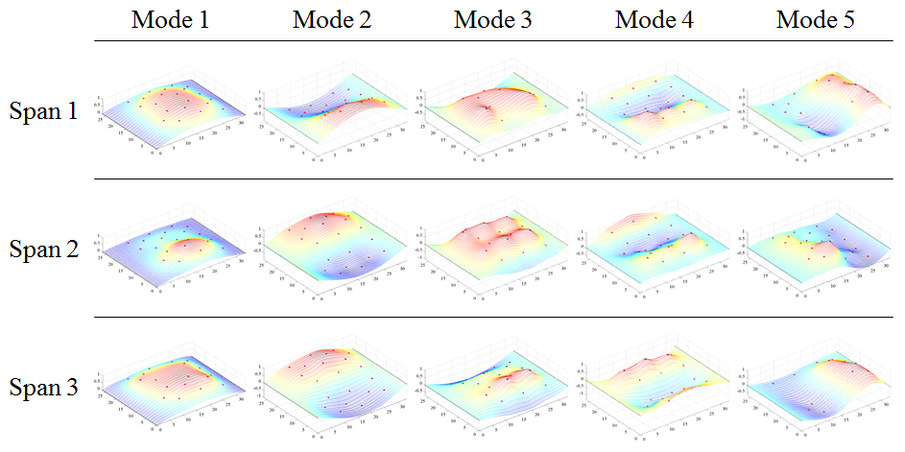

Figure 2. THMPR™ Results – Overview of Global Mode Shapes

Table 2. THMPR™ Results – Identified Natural Frequencies

|  |  |  |  |
| --- | --- | --- | --- |
| **Mode** | **Span 1**  **Frequency [Hz]** | **Span 2**  **Frequency [Hz]** | **Span 3**  **Frequency [Hz]** |
| 1 | 20.41 | 23.34 | 18.95 |
| 2 | 25.88 | 27.83 | 24.9 |
| 3 | 31.54 | 31.25 | 30.57 |
| 4 | 33.11 | 38.96 | 36.91 |
| 5 | 53.81 | 56.93 | 46.58 |

## Load Rating Analysis Summary

The structure was modeled using finite element analysis and computational software. An initial finite element (FE) model was created in Strand7 for all three spans of Northampton County Bridge 063 using the RAMPS software package developed at Drexel University as part of a National Institute of Standards and Technology Innovation Program (NIST-TIP) and the National Cooperative Highway Research Program Project 12-103 (NCHRP 12-103). Conservative material properties, section properties, and boundary conditions were assumed for an initial model. The 3D geometric model (Figure 3) utilizes beam elements for the steel I-section and concrete encasement. Shell elements are used to model the deck and concrete curb. Rigid links as well as beam elements with variable stiffness are used to enforce compatibility of the displacements between the various structural elements.

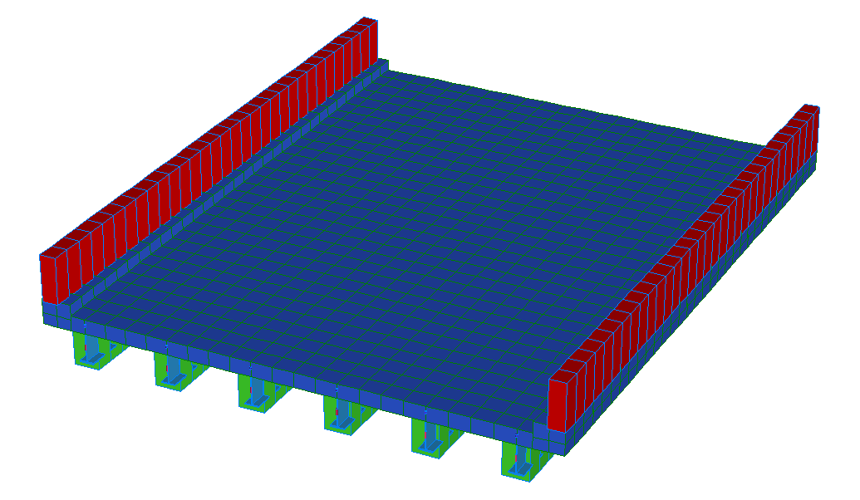

Y

X

Z

Figure 3. *A Priori* FE Model of single span of Bridge 063.

The initial model was rated for AASHTO Load and Resistance Factor Strength I and Service II limit states for an HL-93 truck. It was then calibrated to the natural frequencies and mode shapes developed through experimentation. A set of calibrated models were used to perform live load ratings. The six calibrated models with strong objective function and final parameter agreement were rated using the RAMPs software. In order to assure the most conservative load rating estimate while utilizing an updated FE model, stiffness and strength contributions from the concrete encasement and barriers were ignored in the ratings for the updated models.

## Appendix B-1 – Bridge Description

Northampton County Bridge 063 is a three span, simply supported, concrete encased steel I-Beam structure. The bridge carries Bushkill Road over Bushkill Creek and has a current posted weight limit of 16 tons. All three spans were measured as 33’-6” span length and a roadway width of 23’-5”. Each span carries a curb measuring 4.75”x6.5” with a monolithic barrier of 29”x10” on either side of the roadway (Figure 4). The overall deck thickness was measured to be approximately 14” with a 4.75” overlay, implying the deck is 9”. Each span has six (6) concrete encased steel I-beams spaced at 4’-4” (Figure 5) with overall dimensions of 14.5”x21.5”. Each girder has what appears to be 1-2” of shotcrete applied to the surface of the original concrete encasement at a time unknown to the engineer. No apparent cracks were observed in the shotcrete cover for any of the girders. The presence of shotcrete over the original concrete encasement may imply that some deterioration of the encasement was present. This bridge has no skew.

No original plans exist for the bridge; however STV Inc. produced a Load Rating Summary performed in 2012 that details the structure cross-section. In their load rating, STV noted that Northampton County produced approximate beam dimensions after taking cores of the structure. Measurements taken in the field agreed with those reported by STV Inc.

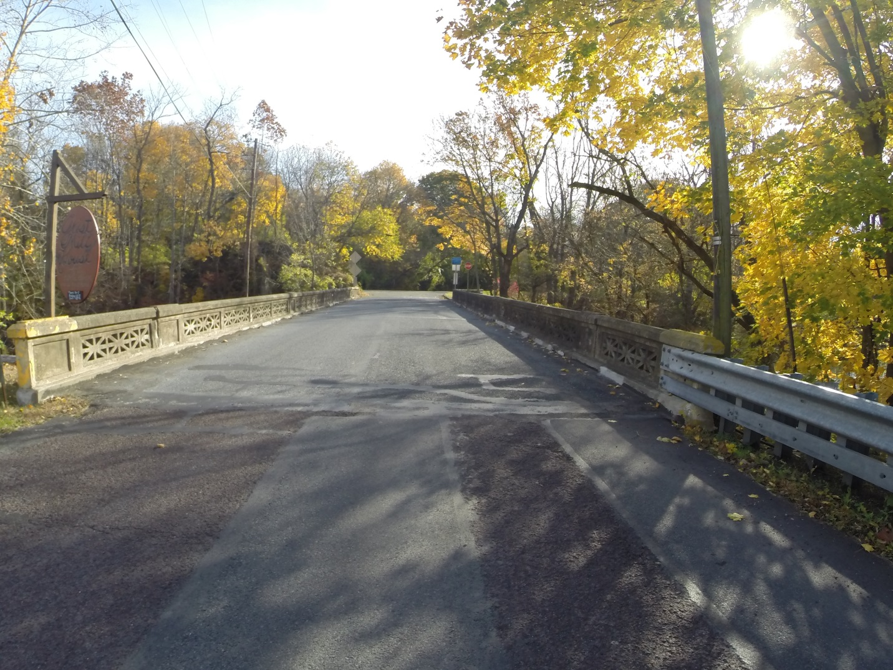

Figure 4. Northampton County Bridge 063

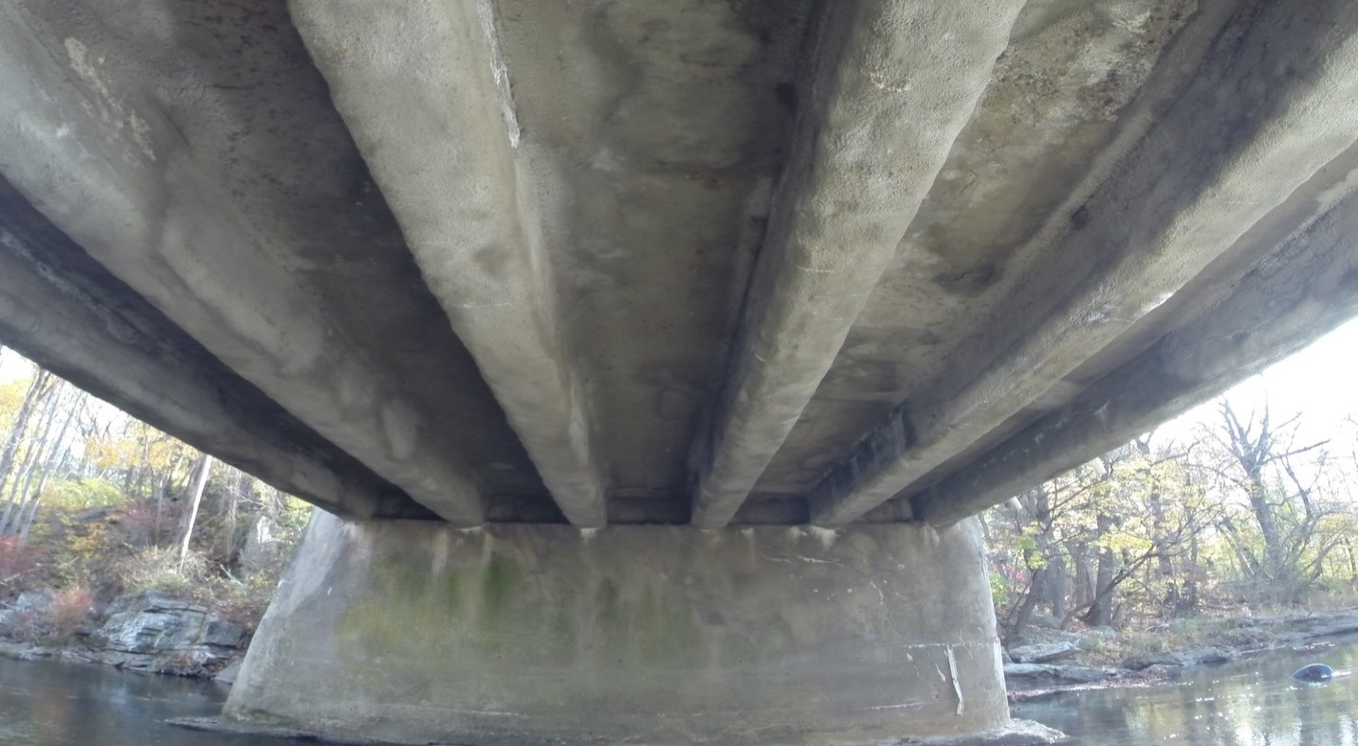

Figure 5. Underside view of Northampton County Bridge 063

## Appendix B-2 – Bridge 063 Experimental Evaluation

Northampton County Bridge 063 was evaluated using vibration testing methods. The bridge was dynamically excited at several locations on the deck surface using a broad band impact force, and its corresponding vibration responses were measured using accelerometers that were also located on the deck. The combined input-output vibration measurements were subsequently analyzed to extract the dynamic properties of the structure which were then used to calibrate a finite element model of the bridge. Details of the experimental setup, the test execution and the data analysis methods employed for the bridge are provided in the following sections.

### Description of Test Equipment - THMPR™ System

The Targeted Hits to Measure Performance Responses (THMPR™) system is a self-contained rapid modal testing trailer and streamlined data processing software which extracts modal parameters, such as frequencies and mode shapes, of a structure. The extracted modal parameters may then be used to determine anomalous behavior as well as provide experimental data for finite element model calibration. The system, shown in Figure 6, is comprised of a physical test device which utilizes a significantly reconfigured Falling Weight Deflectometer trailer with modifications to (1) provide a single, large (~30 kip) broadband impact source, and (2) collect the resulting free-decay response of the bridge’s surface in a spatially distributed manner (and in-turn be able to capture local mode shapes). The local sensor array is shown in Figure 7. The trailer is towed along the bridge deck and single-input-multiple-output (SIMO) impact testing is performed at targeted locations. The data is wirelessly acquired at each location and passed to semi-automated modal processing software which performs (1) data quality checks, (2) frequency response function development and (3) modal parameter estimation. The local mode shapes are then linearly combined into a final global modal parameter set utilizing selected stationary references previously secured along an available sidewalk and cabled to an independent, GPS synchronized data acquisition.



Figure 6. THMPR™ System - Primary Components



Figure 7. THMPR™ Local Sensor Array

### Instrumentation

The typical instrumentation plan for a single span is shown in Figure 8. A total of three stationary reference accelerometers were used for each of the three spans. The references were temporarily attached to the bridge deck using glue adhesive at the quarter span, mid span, and three-quarter span locations. The reference accelerometers remained at the same locations on the deck throughout the vibration testing and were used to link together the vibrations measured by THMPR™’s local sensor array of six accelerometers (Figure 7). The reference accelerometers were cabled to a local GPS synchronized data acquisition system along the shoulder and out of the way of traffic.

A total of six impact locations were selected for the test: (1) at quarter span in the right lane, (2) at mid span in the right lane, (3) at three-quarter span in the right lane, (4) at quarter span in the left lane, (5) at mid span in the left lane, and (6) at three-quarter span in the left lane. The impact locations were chosen so that the measured vibration responses would have a dense spatial resolution and to vary the spatial characteristics of the input excitation. The former consideration is important for resolving different mode shapes from the vibration measurements, while the latter is important for exciting different vibration modes. Note, only three of the six local output sensors were required for data analysis.

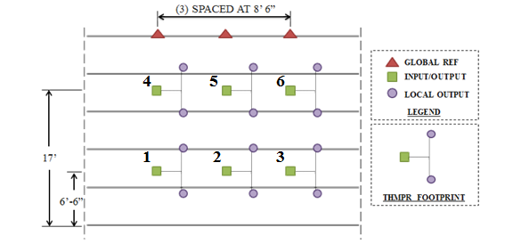

Figure 8. Typical Instrumentation Plan

### Test Execution

THMPR™ system testing was conducted on November 4, 2014. THMPR™’s impact head was centered above a selected impact location on the deck and the GPS synchronized accelerometer array attached to THMPR™ was remotely deployed. This lowered the six accelerometer housings onto the bridge deck and compressed them against the surface (Figure 9). The impact force and bridge vibration measurements were recorded at a rate of 3,200 samples per second (Hz) for each span in order to precisely define the shape of the impulse signal and for a duration of 10 seconds to ensure the complete capture of the structure’s post-impact free vibration decay response. A total of three separate impacts were recorded for averaging and noise reduction purposes at each of the six locations for each of the three spans.

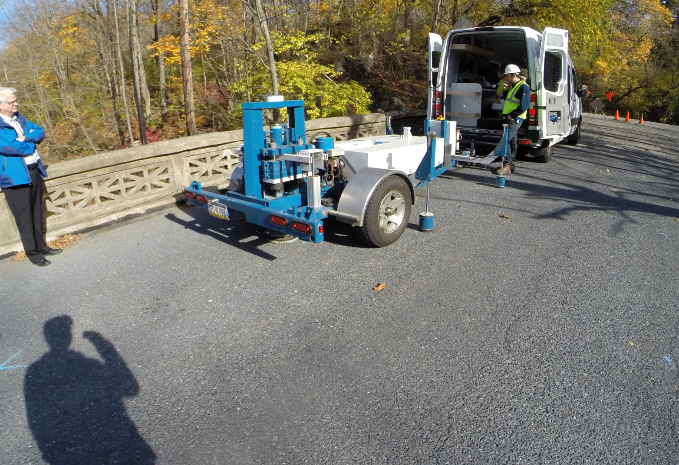

SENSOR HOUSING

Figure 9. THMPR™ System Test Execution

### Data Quality

Typical impact forces of up to 25,000 lbs. were observed (Figure 10A) with an approximate usable frequency range of 0-60 Hz (Figure 10B). The impact forces produced by THMPR™ also resulted in bridge acceleration magnitudes of up to 4 g’s (Figure 11A). Frequency content of the structural response (Figure 11B) shows clearly defined, smooth peaks of resonance which indicates linearity, adequate frequency resolution, and good excitation of all fundamental modes of interest. The relatively large structural response and the acquisition of ten second time windows provided a frequency resolution of 0.09 Hz which resulted in good characterization of closely spaced modes.

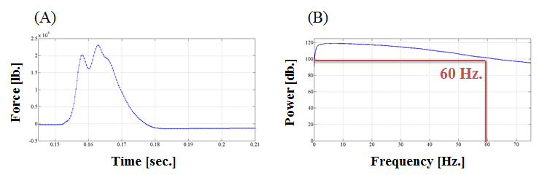

Figure 10. (A) Typical Force Time History & (B) Typical Force Frequency Content

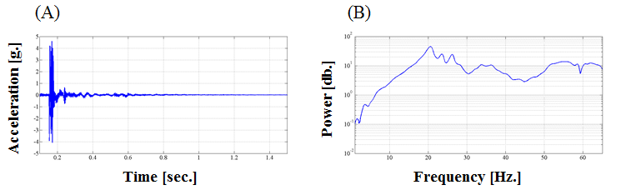

Figure 11. (A) Typical Response Time History & (B) Typical Response Frequency Content

### Modal Parameter Identification

The modal parameters for the structure were identified from the vibration measurements onsite after completion of the testing to provide immediate feedback on the data quality, structural response of the bridge, and operating condition of the test equipment to the on-site engineers. The modal parameters include the natural frequencies and the modal vectors (mode shapes) for each mode. These parameters are directly related to the in-situ mass and stiffness characteristics of the bridge, and are used for calibrating the FE model of the structure.

The modal parameter identification process starts with the computation of frequency response functions for each input-output measurement pair. A frequency response function is essentially the frequency domain transform of measured acceleration response at each sensor location divided by the measured impact force for each test location. The Complex Mode Indicator Function (CMIF) was then calculated for each test location (Figures 12, 13, & 14) using the frequency response functions created in the previous step. The CMIF is computed by singular value decomposition of the matrix of frequency response functions for each test location. The largest singular values are plotted against frequency to create the CMIF plot. Each peak in the CMIF plot represents a possible mode of vibration for the structure and the amplitude of the singular value is directly related to the dominance of the corresponding modal vector at that test location. The singular values for each independent impact location are super imposed to compare areas of resonance and ultimately select global modal parameters. Additionally, in regions of high modal density, modal vectors associated with large singular values were plotted spatially and compared in order to determine the appropriate selection of the dominant global mode in that region. A total of five global vibration modes for span 1, span 2, and span 3 (global poles) were identified from the CMIF plots as shown in Figure 12, Figure 13, and Figure 14.

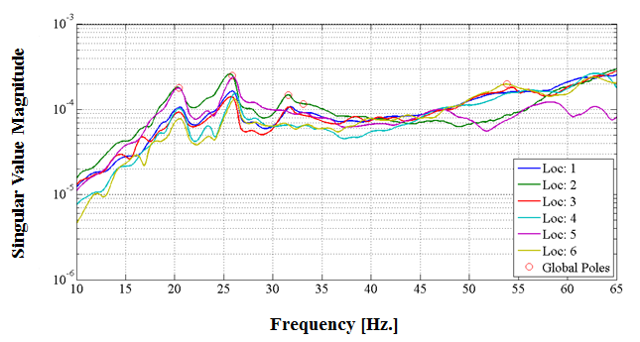

Figure 12. Span 1 – Complex Mode Indicator Function (CMIF)

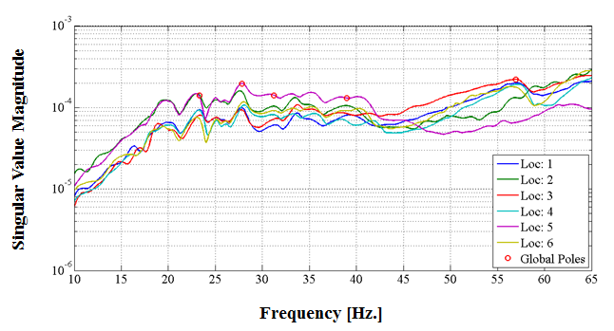

Figure 13. Span 2 – Complex Mode Indicator Function (CMIF)

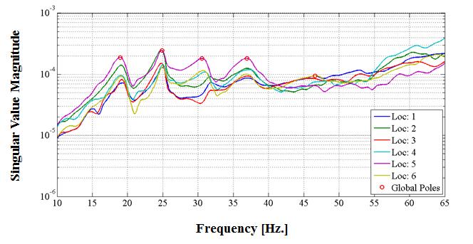

Figure 14. Span 3 – Complex Mode Indicator Function (CMIF)

For each of the spans, local mode shapes for each impact location were extracted at each global pole and combined into a global parameter set. Master mode shapes were selected for each mode based on the relative amplitude of the CMIF singular value for each impact location. The impact location associated with the largest CMIF amplitude for a specific vibration mode contains the highest signal to noise ratio and the corresponding mode shape was designated the master shape for that vibration mode. For each global pole, the modal amplitudes of the stationary references were compared between the local master mode shape and the remaining local mode shapes. A scaling coefficient was developed via a least squares approximation and used to linearly integrate the independent local mode shapes into the local master mode shape and form a global parameter set. Local mode shapes extracted from impact locations which coincided with a point of zero displacement (nodal point) for a particular mode were discarded and not included within the global modal parameter set. Additionally, a combination of the stationary references for each master local mode shape was chosen on an individual mode basis to avoid using reference sensors in locations of low modal amplitude for a particular mode. The first five fundamental global mode shapes and corresponding frequencies for each of the three spans occur within the frequency band of 0-60 Hz. Span 1 global mode shapes and frequencies are shown in Figure 15 and Table 4, respectively. Span 2 global mode shapes and frequencies are shown in Figure 16 and Table 5, respectively. Span 3 global mode shapes and frequencies are shown in Figure 17 and

Table 6, respectively. It should be noted that the interstitial areas between the discrete experimental degrees-of-freedom for the mode shapes were interpolated using a fourth order equation to aid in the visualization of these shapes.

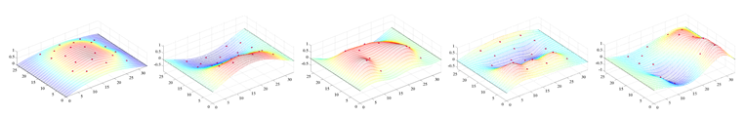

Figure 15. Span 1 – THMPR™ Results - Global Mode Shapes

Table 4. Span 1 – THMPR™ Results – Identified Natural Frequencies

|  |  |  |  |
| --- | --- | --- | --- |
| **Mode** | **Frequency [Hz]** | **Master**  **Location** | **Included Locations** |
| 1 | 20.41 | 5 | 1 2 3 4 5 6 |
| 2 | 25.88 | 2 | 1 2 3 4 5 6 |
| 3 | 31.54 | 1 | 1 3 4 5 |
| 4 | 33.11 | 2 | 1 2 3 4 5 6 |
| 5 | 53.81 | 6 | 1 3 4 6 |

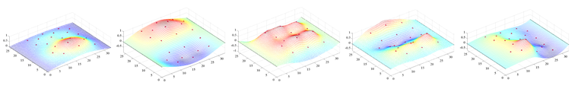

Figure 16. Span 2 – THMPR™ Results – Global Mode Shapes

Table 5. Span 2 – THMPR™ Results – Identified Natural Frequencies

|  |  |  |  |
| --- | --- | --- | --- |
| **Mode** | **Frequency [Hz]** | **Master**  **Location** | **Included Locations** |
| 1 | 23.34 | 2 | 1 2 3 4 5 6 |
| 2 | 27.83 | 5 | 1 2 3 4 5 6 |
| 3 | 31.25 | 5 | 1 2 3 4 5 6 |
| 4 | 38.96 | 5 | 1 2 3 4 5 6 |
| 5 | 56.93 | 3 | 1 2 3 4 5 6 |

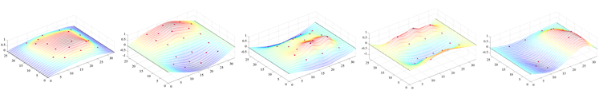

Figure 17. Span 3 – THMPR™ Results – Global Mode Shapes

Table 6. Span 3 – THMPR™ Results – Identified Natural Frequencies

|  |  |  |  |
| --- | --- | --- | --- |
| **Mode** | **Frequency [Hz]** | **Master**  **Location** | **Included Locations** |
| 1 | 18.95 | 2 | 1 2 3 4 6 |
| 2 | 24.9 | 5 | 1 2 3 4 5 6 |
| 3 | 30.57 | 5 | 1 2 3 4 5 6 |
| 4 | 36.91 | 5 | 1 2 3 4 5 6 |
| 5 | 46.58 | 1 | 1 3 6 |

## Appendix B-3 – Model Updating

Five modes from the model were paired with the experiment. The table below shows the paired analytical shapes from the *a priori* and updated models for Span 1. Spans 2 and 3 have similar modal properties. Frequency differences between experiment and *a priori* model were in the range of negative 30 to negative 60 percent, indicating that the *a priori* model had lower global stiffness than the *in situ* structure. Mode shapes were used to pair frequencies between the FE model and experiment while the frequencies themselves were used for parameter estimation.

The updated Span 1 model exhibited resultant frequencies that were anywhere from 40 percent lower to 20 percent higher than the experiment. The longitudinally dominated mode shapes had higher-than-experimental frequencies while the transverse dominated modes had the lower-than-experimental frequencies. This indicates that overall global stiffness in the model along the main load path is higher than that of the actual structure while transverse load sharing in the model among girders is less than that of the in situ structure. As a result, the stiffness contribution from the concrete encasement in the model was neglected during rating to maintain a conservative estimate of global, longitudinal live load resistance.

The updated Span 2 and Span 3 models exhibited lower frequencies than the experiment for the majority of modes, with higher-than-experiment frequencies having a small error value. The frequencies were closer to the experiment for both Span 2 and 3 updated models than the *a priori* model. The concrete encasement was neglected during rating for Spans 2 and 3 to ensure a conservative estimate.

The objective function values from the updating algorithm for all three spans showed an improvement over the *a priori* model, indicating that the accuracy of the final updated models were higher than that of the *a priori* model.

Table 7. Typical Mode Shapes

|  |  |  |  |
| --- | --- | --- | --- |
| A-Priori Shapes | Mode Number | Typical Updated Model Shapes | Mode Number |
|  | **1** |  | **1** |
|  | **2** |  | **2** |
|  | **4** |  | **5** |
|  | **3** |  | **4** |
|  | **5** |  | **10** |

## Appendix B-4 – Bridge Geometry and Material Properties

|  |  |  |  |
| --- | --- | --- | --- |
|  | Int/Ext | Notes |  |
| **Material Properties** | |  |  |
| Steel Fy (psi) | 30000 | Per AASHTO suggestion |  |
| Concrete f'c (psi) | 2500 | Per AASHTO suggestion |  |
| Concrete Modulus (psi) | 2850000 |  |  |
| Weight of Concrete (lb/ ft3) | 150 |  |  |
| Weight of Steel (lb/ft3) | 490 |  |  |
| **Beam Cross Section** | |  |  |
| Deck Offset* (in.) | -5.5 |  |  |
| Deck thickness (in.) | 9 |  |  |
| Effective width (in.) | 52 | / 53 |  |
| Flange thickness (in.) | 0.741 |  |  |
| Flange width (in.) | 8.7 |  |  |
| Web thickness (in.) | 0.37 |  |  |
| Web depth (in.) | 22.518 |  |  |
| Encasement width (in.) | 16 |  |  |
| Encasement depth (in.) | 20.5 |  |  |
| Distance from Top of Slab to PNA (in.) | 4.0175 |  |  |
| Girder Moment of Inertia (in4) | 2096.4 |  |  |
| Composite Yield Moment (lb-in) | 6049460 | / 6056973 |  |
| Composite Plastic Moment Capacity (lb-in) | 8103966 | / 8117901 |  |
| **Bridge Cross Section** | |  |  |
| Wearing Surface | 4.75 |  |  |
| Out-to-Out Width (in.) | 314 |  |  |
| Road Width (in.) | 281 |  |  |
| Barrier Height (in.) | 29 |  |  |
| Barrier width(in.) | 10 |  |  |
| Curb Height (in.) | 4.75 |  |  |
| Girder Spacing (in.) | 52 |  |  |
| Number of Girders | 6 |  |  |
| Number of Lanes | 2 |  |  |
|  |  |  |  |
| * Distance from top of flange to bottom of deck (values<0 indicate flange embedded in deck) | | | |

## Appendix B-5 – LRFR Rating Details

Table 8: Span 1 Updated Composite LRFR Rating Factors

|  |  |  |  |  |  |  |
| --- | --- | --- | --- | --- | --- | --- |
| Girder # | 1 | 2 | 3 | 4 | 5 | 6 |
| **Limit State: Strength 1 Load Rating Factors** | | | | | | |
| Inv. | 1.23 | 1.48 | 1.41 | 1.41 | 1.48 | 1.23 |
| Op. | 1.60 | 1.92 | 1.83 | 1.83 | 1.92 | 1.60 |
| **Limit State: Service 2 Load Rating Factors** | | | | | | |
| Inv. | 1.03 | 1.27 | 1.23 | 1.23 | 1.27 | 1.03 |
| Op. | 1.33 | 1.65 | 1.60 | 1.60 | 1.65 | 1.33 |

Table 9: Span 1 Updated Composite LRFR Demands

|  |  |  |  |  |  |  |
| --- | --- | --- | --- | --- | --- | --- |
| Girder # | 1 | 2 | 3 | 4 | 5 | 6 |
| **Moment Demands (lb-in)** | | | | | | |
| DL | 873855.93 | 859313.21 | 858203.02 | 858240.35 | 859327.09 | 873851.08 |
| SDL | 862398.02 | 644327.63 | 528638.07 | 528640.61 | 644330.40 | 862397.85 |
| DLW | 293883.54 | 322506.18 | 341495.60 | 341497.26 | 322508.24 | 293884.53 |
| LL | 2515264.08 | 2189500.32 | 2343807.82 | 2343817.99 | 2189512.48 | 2515265.57 |
| **Stress Demands (psi)** | | | | | | |
| DL | 5201.33 | 5087.96 | 4926.62 | 4926.82 | 5088.03 | 5201.11 |
| SDL | 4414.5 | 3317.9 | 2712.39 | 2712.41 | 3317.91 | 4414.5 |
| DLW | 1502.81 | 1647.43 | 1738.86 | 1738.87 | 1647.45 | 1502.82 |
| LL | 13044 | 11148.3 | 11983.6 | 11983.6 | 11148.4 | 13044 |

Table 10: Span 1 Updated Composite LRFR Capacity

|  |  |
| --- | --- |
| Yield Stress Limit for Service State Capacity (psi): | 30000 |
| **Strength 1 Capacity of Exterior Girders** | |
| Stress Limit for Positive Moment Region (psi): | 30000 |
| Moment Limit for Positive Moment Region (lb-in): | 8045734 |
| **Strength 1 Capacity of Interior Girders** | |
| Stress Limit for Positive Moment Region (psi): | 30000 |
| Moment Limit for Positive Moment Region (lb-in): | 8027385 |

Table 11: Span 2 Updated Composite LRFR Rating Factors

|  |  |  |  |  |  |  |
| --- | --- | --- | --- | --- | --- | --- |
| Girder # | 1 | 2 | 3 | 4 | 5 | 6 |
| **Limit State: Strength 1 Load Rating Factors** | | | | | | |
| Inv. | 1.34 | 1.55 | 1.51 | 1.51 | 1.55 | 1.34 |
| Op. | 1.73 | 2.00 | 1.95 | 1.95 | 2.00 | 1.73 |
| **Limit State: Service 2 Load Rating Factors** | | | | | | |
| Inv. | 1.13 | 1.35 | 1.33 | 1.33 | 1.35 | 1.13 |
| Op. | 1.47 | 1.75 | 1.73 | 1.73 | 1.75 | 1.47 |

Table 12: Span 2 Updated Composite LRFR Demands

|  |  |  |  |  |  |  |
| --- | --- | --- | --- | --- | --- | --- |
| Girder # | 1 | 2 | 3 | 4 | 5 | 6 |
| **Moment Demands (lb-in)** | | | | | | |
| DL | 873847.6 | 859322.8 | 858200.1 | 858243.7 | 859317 | 873844.2 |
| SDL | 795781.5 | 632809.5 | 541189.3 | 541189.3 | 632809.6 | 795781.4 |
| DLW | 291776.6 | 310368 | 323686.5 | 323686.4 | 310368.1 | 291776.6 |
| LL | 2360858 | 2105468 | 2195152 | 2195152 | 2105468 | 2360857 |
| **Stress Demands (psi)** | | | | | | |
| DL | 5201.29 | 5088.01 | 4926.61 | 4926.84 | 5087.98 | 5201.07 |
| SDL | 4031.73 | 3216.29 | 2742.08 | 2742.08 | 3216.29 | 4031.73 |
| DLW | 1474.07 | 1568.01 | 1632.05 | 1632.05 | 1568.01 | 1474.07 |
| LL | 12111.3 | 10621.4 | 11100.6 | 11100.6 | 10621.4 | 12111.3 |

Table 13: Span 2 Updated Composite LRFR Capacity

|  |  |
| --- | --- |
| Yield Stress Limit for Service State Capacity (psi): | 30000 |
| **Strength 1 Capacity of Exterior Girders** | |
| Stress Limit for Positive Moment Region (psi): | 30000 |
| Moment Limit for Positive Moment Region (lb-in): | 8045734 |
| **Strength 1 Capacity of Interior Girders** | |
| Stress Limit for Positive Moment Region (psi): | 30000 |
| Moment Limit for Positive Moment Region (lb-in): | 8027385 |

Table 14: Span 3 Updated Composite LRFR Rating Factors

|  |  |  |  |  |  |  |
| --- | --- | --- | --- | --- | --- | --- |
| Girder # | 1 | 2 | 3 | 4 | 5 | 6 |
| **Limit State: Strength 1 Load Rating Factors** | | | | | | |
| Inv. | 1.34 | 1.55 | 1.51 | 1.51 | 1.55 | 1.34 |
| Op. | 1.73 | 2.00 | 1.95 | 1.95 | 2.00 | 1.73 |
| **Limit State: Service 2 Load Rating Factors** | | | | | | |
| Inv. | 1.13 | 1.35 | 1.33 | 1.33 | 1.35 | 1.13 |
| Op. | 1.47 | 1.75 | 1.73 | 1.73 | 1.75 | 1.47 |

Table 15: Span 3 Updated Composite LRFR Demands

|  |  |  |  |  |  |  |
| --- | --- | --- | --- | --- | --- | --- |
| Girder # | 1 | 2 | 3 | 4 | 5 | 6 |
| **Moment Demands (lb-in)** | | | | | | |
| DL | 873856.39 | 859319.06 | 858205.03 | 858241.12 | 859323.04 | 873850.3 |
| SDL | 795781.2 | 632810 | 541190.33 | 541191.29 | 632811.89 | 795783.8 |
| DLW | 291776.48 | 310368.4 | 323687.15 | 323687.6 | 310369.21 | 291777.6 |
| LL | 2360856.99 | 2105469.88 | 2195156.32 | 2195158.88 | 2105475.04 | 2360864 |
| **Stress Demands (psi)** | | | | | | |
| DL | 5201.33 | 5087.99 | 4926.63 | 4926.83 | 5088.01 | 5201.11 |
| SDL | 4031.73 | 3216.3 | 2742.09 | 2742.09 | 3216.3 | 4031.75 |
| DLW | 1474.07 | 1568.02 | 1632.05 | 1632.05 | 1568.02 | 1474.08 |
| LL | 12111.3 | 10621.4 | 11100.6 | 11100.6 | 10621.4 | 12111.3 |

Table 16: Span 3 LRFR Capacity

|  |  |
| --- | --- |
| Yield Stress Limit for Service State Capacity (psi): | 30000 |
| **Strength 1 Capacity of Exterior Girders** | |
| Stress Limit for Positive Moment Region (psi): | 30000 |
| Moment Limit for Positive Moment Region (lb-in): | 8045734 |
| **Strength 1 Capacity of Interior Girders** | |
| Stress Limit for Positive Moment Region (psi): | 30000 |
| Moment Limit for Positive Moment Region (lb-in): | 8027385 |

## Appendix B-5 – Distribution Factors

To provide a point of comparison between the FE model-based LRFR ratings and their single-line girder counterparts, the effective distribution factors were computed. These distribution factors represent the portion of a lane that must be assumed to be carried by interior/exterior girders within the single-line girder model to produce the same governing live load moments produced by the FE model. Table X provides a summary of the maximum interior and exterior effective distribution factors together with the distribution factors reference by the AASHTO LRFD Bridge Design Specifications.

Table 27: Comparison of effective distribution factors and AASHTO specified distribution factors

|  |  |  |  |  |  |
| --- | --- | --- | --- | --- | --- |
|  | **Effective** | | | **STV** | **AASHTO** |
|  | **Span 1** | **Span 2** | **Span 3** |
| Interior | 0.4106 | 0.3846 | 0.4106 | 0.390 | 0.4483 |
| Exterior | 0.4407 | 0.4136 | 0.4407 | 0.390 | 0.4483 |

**PAGE INTENTIONALLY LEFT BLANK**

# Appendix C – Bridge 076 Performance Evaluation and Load Rating Analysis

**Northampton County Bridge 076**

|  |  |
| --- | --- |
| **BMS No:** | **48720306309076** |
| **Feature Carried:** | E. Aluta Mill Road |
| **Feature Intersected:** | Bushkill Creek |
| **Structure Type:** | Concrete Encased Girder |
|  |  |
| **Test Date:** | 11/04/2014 |
| **Test Type:** | Dynamic Test (Forced Vibration) |
| **Analysis and Rating Method:** | AASHTO LRFR |

No plans or drawings were provided for this bridge. Geometry of the bridge and its components were measured in the field on the day of the test. The structure was evaluated using forced vibration testing methods and its dynamic properties (natural frequencies and mode shapes) were extracted for comparison to a finite element model.

Strand7 FE Modelling Software was used in conjunction with computational software to perform a live load rating analysis for all three spans of the bridge. An initial finite element (FE) model was created in Strand7 for the bridge. Conservative material properties, section properties, continuity conditions and boundary conditions were assumed for an initial model. The dynamic properties of the initial model were compared to the experimental data in order to verify conservative global stiffness. Without knowing the steel section located inside the concrete encasement, rating the bridges using conventional means was impossible. It was determined that assuming the unknown steel safely carries all dead loads while assuming the concrete carries the live loads exclusively would provide a sufficiently conservative estimate of live load carrying capacity. Therefore concrete cracking was used as the governing failure mode. **It was determined that the structure may safely carry current legal truck loads without excessive concrete cracking or other serviceability concerns. If AASHTO Strength and Service ratings are required, we recommend further investigation to determine what steel sections are within the concrete.**

## Experimental Evaluation Summary

Northampton County Bridge 076 was evaluated on November 4, 2014 using forced vibration testing methods and the dynamic properties (natural frequencies and mode shapes) were extracted for finite element model calibration.

A self-contained modal impact trailer equipped with a falling mass impact system and local sensor array was used to execute the vibration tests. The superstructure was excited via a 25 kip impulse force at multiple, spatially distributed locations which resulted in up to 4 g’s of bridge deck acceleration. Acceleration responses were measured via a local sensor array of six accelerometers and multiple spatially distributed stationary global references secured to the bridge deck via glue adhesive prior to testing. Local modal parameter estimation was performed utilizing the Complex Mode Indicator Function (CMIF) and integrated into a final global modal parameter set. Three natural frequencies and mode shapes were identified in the frequency band of 0-55 Hz (Figure 2 & Table 1).

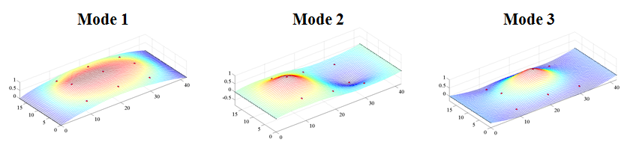

Figure 2. THMPR™ Results – Overview of Global Mode Shapes

Table 1. THMPR™ Results – Identified Natural Frequencies

|  |  |
| --- | --- |
| **Mode** | **Span 1**  **Frequency [Hz]** |
| 1 | 13.38 |
| 2 | 17.48 |
| 3 | 20.18 |

## Load Rating Analysis Summary

The structure was modeled using finite element analysis and computational software. An initial finite element (FE) model was created in Strand7 for Northampton County Bridge 076 using the RAMPS software package developed at Drexel University as part of a National Institute of Standards and Technology Innovation Program (NIST-TIP) and the National Cooperative Highway Research Program Project 12-103 (NCHRP 12-103). Conservative material properties, section properties, continuity conditions and boundary conditions were assumed for an initial model. The 3D geometric model (Figure 3) utilizes beam elements for the concrete encased girders and transverse floor beams. Shell elements are used to model the deck and concrete curb. Rigid links as well as beam elements with variable stiffness are used to enforce compatibility of the displacements between the various structural elements.

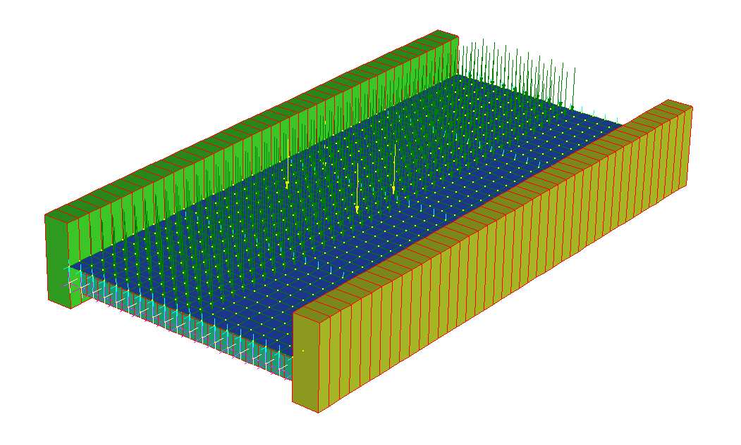

Y

X

Z

Figure 3. *A Priori* FE Model of single span of Bridge 076.

The model used for rating exhibited lower natural frequencies than the experimental results, indicating that the global stiffness of the actual structure is higher than that of the model and that the model is a conservative estimate of global behavior in response to static loads.

Due to the lack of design details for the girder or any reinforcement, concrete stress under wearing surface dead load and AASHTO HL-93 live load were simulated. This analysis assumes that the unknown steel within the structure safely carries the dead load due to steel and concrete while the concrete carries the entirety of wearing surface dead load and live load. Concrete stress in the model was compared to a conservative cracking limit of 300 psi and was found to be under this limit.

## Appendix C-1 – Bridge Description

Northampton County Bridge 076 is a concrete encased girder bridge with unknown reinforcement. It carries East Aluta Mill Road over Bushkill Creek. The bridge is approximate 41 feet long with a roadway with of 16.5 feet. The concrete encased through-girders are 73 inches high and 24 inches wide at mid-span. The bridge has a concrete deck of approximately 9 inches thick with a 1-5 inch thick asphalt overlay. Three transverse floor beams that are approximately 18 inches high and 13 inches wide run under the deck.

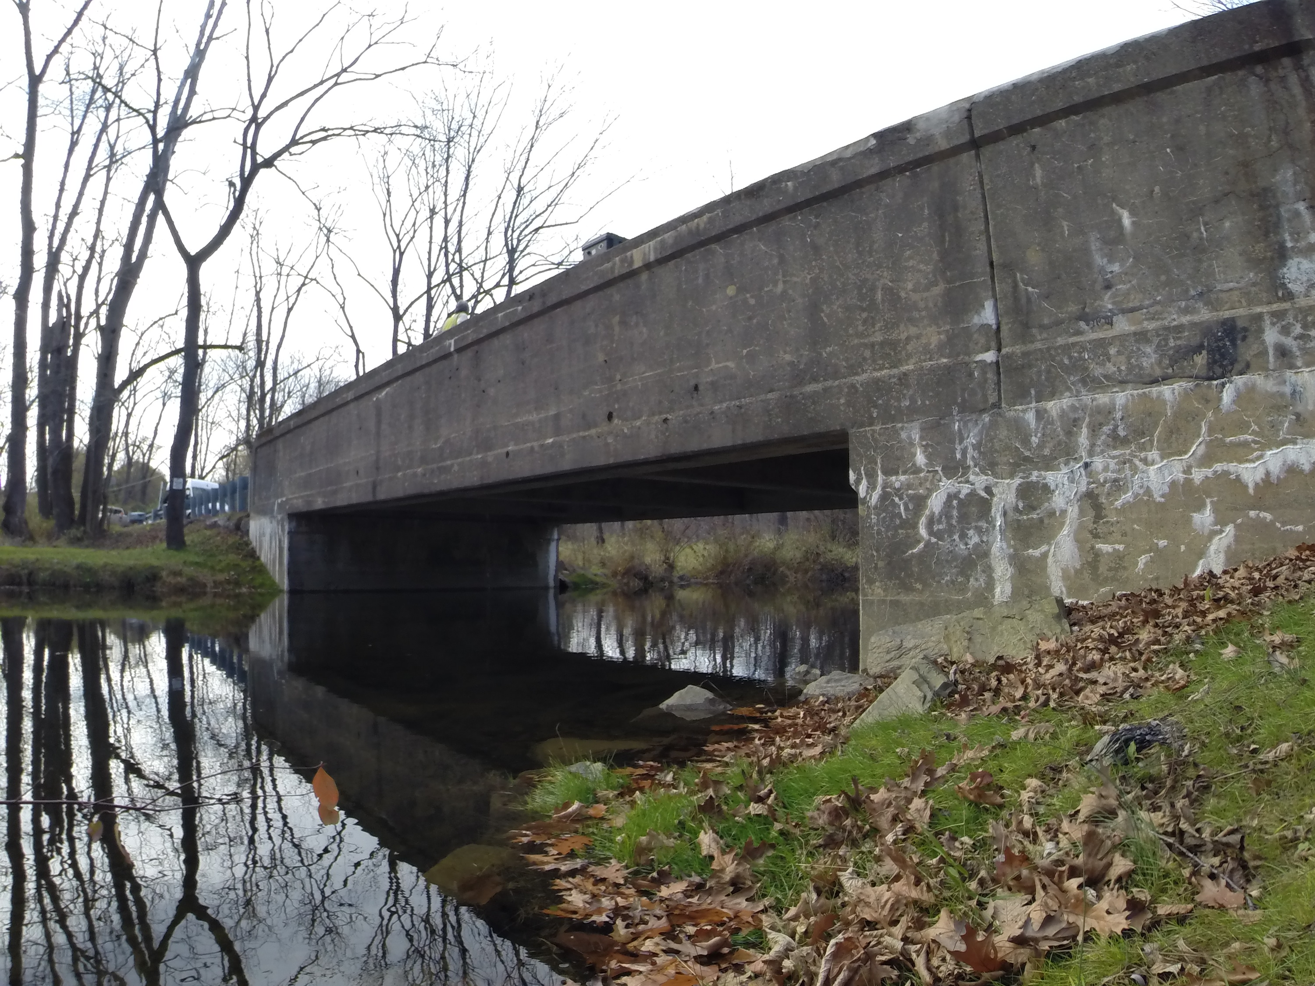

Figure 4. Northampton County Bridge 076

## Appendix C-2 – Experimental Evaluation

Northampton County Bridge 076 was evaluated using vibration testing methods. The bridge was dynamically excited at several locations on the deck surface using a broad band impact force, and its corresponding vibration responses were measured using accelerometers that were also located on the deck. The combined input-output vibration measurements were subsequently analyzed to extract the dynamic properties of the structure which were then used to calibrate a finite element model of the bridge. Details of the experimental setup, the test execution and the data analysis methods employed for the bridge are provided in the following sections.

### Description of Test Equipment - THMPR™ System

The Targeted Hits to Measure Performance Responses (THMPR™) system is a self-contained rapid modal testing trailer and streamlined data processing software which extracts modal parameters, such as frequencies and mode shapes, of a structure. The extracted modal parameters may then be used to determine anomalous behavior as well as provide experimental data for finite element model calibration. The system, shown in Figure 5, is comprised of a physical test device which utilizes a significantly reconfigured Falling Weight Deflectometer trailer with modifications to (1) provide a single, large (~30 kip) broadband impact source, and (2) collect the resulting free-decay response of the bridge’s surface in a spatially distributed manner (and in-turn be able to capture local mode shapes). The local sensor array is shown in Figure 6. The trailer is towed along the bridge deck and single-input-multiple-output (SIMO) impact testing is performed at targeted locations. The data is wirelessly acquired at each location and passed to semi-automated modal processing software which performs (1) data quality checks, (2) frequency response function development and (3) modal parameter estimation. The local mode shapes are then linearly combined into a final global modal parameter set utilizing selected stationary references previously secured along an available sidewalk and cabled to an independent, GPS synchronized data acquisition.



Figure 5. THMPR™ System - Primary Components



Figure 6. THMPR™ Local Sensor Array

### Instrumentation

The typical instrumentation plan for a single span is shown in Figure 7. A total of six stationary reference accelerometers were temporarily attached to the bridge deck using glue adhesive at the quarter span, mid span, and three-quarter span locations along each sidewalk. The reference accelerometers remained at the same locations on the deck throughout the vibration testing and were used to link together the vibrations measured by THMPR™’s local sensor array of six accelerometers (Figure 6). The reference accelerometers were cabled to GPS synchronized data acquisition systems along each shoulder and out of the way of traffic.

A total of three impact locations were selected at the quarter span, mid span, and three-quarter span lengths along center lane of the superstructureFigure . The impact locations were chosen so that the measured vibration responses would have a dense spatial resolution and to vary the spatial characteristics of the input excitation. The former consideration is important for resolving different mode shapes from the vibration measurements, while the latter is important for exciting different vibration modes. Note, due to the short length of the span and limited lane access, only a single input/output measurement was required at each location for the analysis.

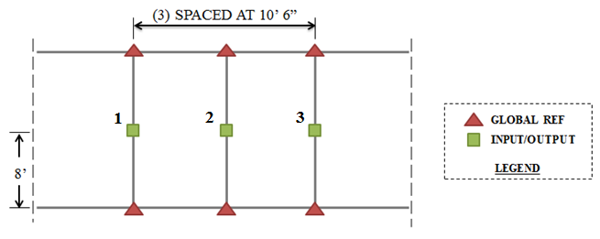

Figure 7 Typical Instrumentation Plan

### Test Execution

THMPR™ system testing was conducted on November 4, 2014. THMPR™’s impact head was centered above a selected impact location on the deck and the GPS synchronized accelerometer array attached to THMPR™ was remotely deployed. This lowered the six accelerometer housings onto the bridge deck and compressed them against the surface. The impact force and bridge vibration measurements were recorded at a rate of 3,200 samples per second (Hz) in order to precisely define the shape of the impulse signal and for a duration of 10 seconds to ensure the complete capture of the structure’s post-impact free vibration decay response. A total of three separate impacts were recorded for averaging and noise reduction purposes at each of the nine locations.

### Data Quality

Typical impact forces of up to 25,000 lbs. were observed (Figure 8A) with an approximate usable frequency range of 0-55 Hz (Figure 8B). The impact forces produced by THMPR™ also resulted in bridge acceleration magnitudes of up to 4 g’s (Figure 9A). Frequency content of the structural response (Figure 9B) shows clearly defined, smooth peaks of resonance which indicates linearity, adequate frequency resolution, and good excitation of all fundamental modes of interest. The relatively large structural response and the acquisition of ten second time windows provided a frequency resolution of 0.09 Hz which resulted in good characterization of closely spaced modes.

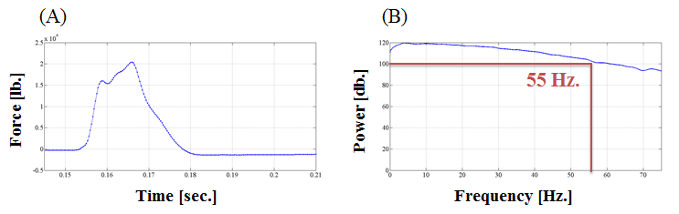

Figure 8. (A) Typical Force Time History & (B) Typical Force Frequency Content

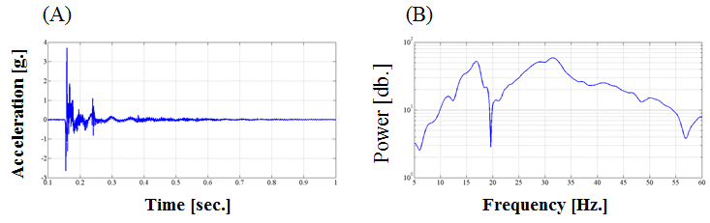

Figure 9. (A) Typical Response Time History & (B) Typical Response Frequency Content

### Modal Parameter Identification

The modal parameters for the structure were identified from the vibration measurements onsite after completion of the testing to provide immediate feedback on the data quality, structural response of the bridge, and operating condition of the test equipment to the on-site engineers. The modal parameters include the natural frequencies and the modal vectors (mode shapes) for each mode. These parameters are directly related to the in-situ mass and stiffness characteristics of the bridge, and are used for calibrating the FE model of the structure.

The modal parameter identification process starts with the computation of frequency response functions for each input-output measurement pair. A frequency response function is essentially the frequency domain transform of measured acceleration response at each sensor location divided by the measured impact force for each test location. The Complex Mode Indicator Function (CMIF) was then calculated for each test location (Figure 10) using the frequency response functions created in the previous step. The CMIF is computed by singular value decomposition of the matrix of frequency response functions for each test location. The largest singular values are plotted against frequency to create the CMIF plot. Each peak in the CMIF plot represents a location of a vibration mode for the structure and the amplitude of the singular value is directly related to the dominance of the corresponding modal vector at that test location. The singular values for each independent impact location are super imposed to compare areas of resonance and ultimately select global modal parameters. A total of three global vibration modes (global poles) identified from the CMIF plots as shown in Figure 10.

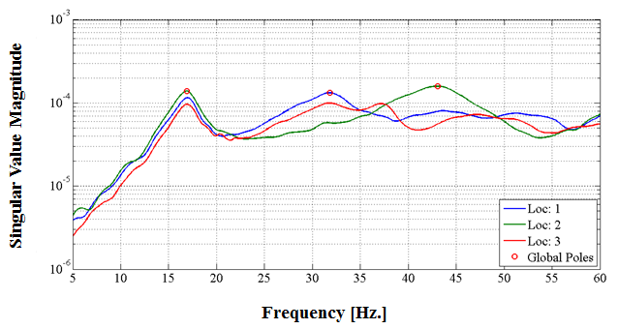

Figure 10. Complex Mode Indicator Function (CMIF)

Local mode shapes for each impact location were extracted at each global pole and combined into a global parameter set. Master mode shapes were selected for each mode based on the relative amplitude of the CMIF singular value for each impact location. The impact location associated with the largest CMIF amplitude for a specific vibration mode contains the highest signal to noise ratio and the corresponding mode shape was designated the master shape for that vibration mode. For each global pole, the modal amplitudes of the stationary references were compared between the local master mode shape and the remaining local mode shapes. A scaling coefficient was developed via a least squares approximation and used to linearly integrate the independent local mode shapes into the local master mode shape and form a global parameter set. Local mode shapes extracted from impact locations which coincided with a point of zero displacement (nodal point) for a particular mode were discarded and not included within the global modal parameter set. Additionally, a combination of the stationary references for each master local mode shape was chosen on an individual mode basis to avoid using reference sensors in locations of low modal amplitude for a particular mode. Global mode shapes and frequencies are shown in Figure 11 and Table 2, respectively. It should be noted that the interstitial areas between the discrete experimental degrees-of-freedom for the mode shapes were interpolated using a fourth order equation to aid in the visualization of these shapes.

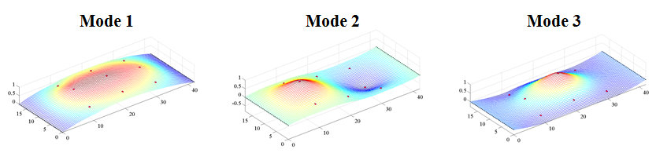

Figure 11. Span 1 – THMPR™ Results - Global Mode Shapes

Table 2. Span 1 – THMPR™ Results – Identified Natural Frequencies

|  |  |  |  |
| --- | --- | --- | --- |
| **Mode** | **Frequency [Hz]** | **Master**  **Location** | **Included Locations** |
| 1 | 16.89 | 2 | 1 2 3 |
| 2 | 31.84 | 1 | 1 3 |
| 3 | 43.07 | 2 | 1 2 |

# Appendix D – Bridge 138 Performance Evaluation and Load Rating Analysis

**Northampton County Bridge 138**

|  |  |
| --- | --- |
| **BMS No:** | 48 721 0564 9138 |
| **Feature Carried:** | Club Road |
| **Feature Intersected:** | Hokendauqua Creek |
| **Structure Type:** | Simply Supported Concrete Encased Steel I-Beam |
|  |  |
| **Test Date:** | 09/08/2014 |
| **Test Type:** | Dynamic Test |
| **Analysis and Rating Method:** | AASHTO LRFR |

Table 1. *A Priori*, and Final Calibrated Model Ratings for all three spans of Bridge 138.

|  |  |  |
| --- | --- | --- |
| **Bridge 138** | Span 1 | |
| Inventory | Operating |
| A-Priori | | |
| Strength I LRFR | 1.63 | 2.11 |
| Service II LRFR | 1.48 | 1.93 |
| Strength I LFR | 1.75 | 2.93 |
| Strength I ASR | 0.79 | 1.62 |
| Updated Composite | | |
| Strength I LRFR | 1.71 | 2.22 |
| Service II LRFR | 1.57 | 2.04 |
| Strength I LFR | 1.83 | 3.05 |
| Strength I ASR | 0.85 | 1.72 |
| Updated Non-Composite | | |
| Strength I LRFR | 1.10 | 1.42 |

Design drawings for this bridge were not available at the time of testing; however, STV Inc. produced a Load Rating Summary performed in 2012 that detailed the structure’s cross section. The geometry of the bridge and its components was verified via field measurements on the day of the test and is summarized in section 4 of this appendix. The structure was evaluated using forced vibration testing methods and the dynamic properties (natural frequencies and mode shapes) were extracted for finite element model calibration.

Strand7 FE Modelling Software was used in conjunction with computational software to perform a live load rating analysis for both spans of the bridge. An initial finite element (FE) model was created in Strand7 for all three spans of the bridge. Conservative material properties, section properties, and boundary conditions were assumed for an initial model. The initial model was rated for AASHTO Load and Resistance Factor Strength I and Service II limit states for an HL-93 truck. The initial model was then calibrated to the natural frequencies and mode shapes developed through experimentation. A set of calibrated models were used to perform live load ratings for each span with and without composite action enforced. Controlling ratings for the initial and calibrated models are summarized in the above table. Distribution factors are provided in section 6 of this appendix.

## Experimental Evaluation Summary

The structure was evaluated on September 8, 2014 using forced vibration testing methods and the dynamic properties (natural frequencies and mode shapes) were extracted for finite element model calibration.

A self-contained modal impact trailer equipped with a falling mass impact system and local sensor array was used to execute the vibration tests. The superstructure was excited via a 25 kip impulse force at multiple, spatially distributed locations which resulted in up to 3 g’s of bridge deck acceleration. Acceleration responses were measured via a local sensor array of six accelerometers and multiple spatially distributed stationary global references secured to the bridge deck via glue adhesive prior to testing. Local modal parameter estimation was performed utilizing the Complex Mode Indicator Function (CMIF) and integrated into a final global modal parameter set. Eight natural frequencies and mode shapes were identified for span 1 and five natural frequencies and mode shapes were identified for span 2 in the frequency band of 0-65 Hz (Figure 2 & Table 2).

Figure 1. THMPR™ System

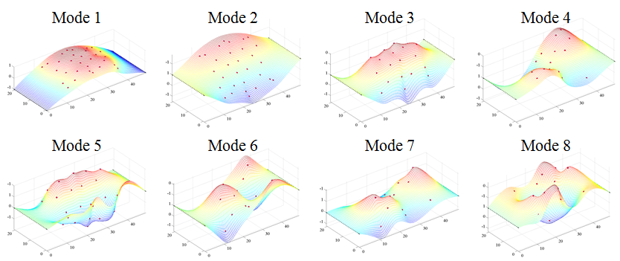

Figure 2 THMPR™ Results - Global Mode Shapes

Table 2. THMPR™ Results – Identified Natural Frequencies

|  |  |  |  |
| --- | --- | --- | --- |
| **Mode** | **Frequency [Hz]** | **Master**  **Location** | **Included Locations** |
| 1 | 9.67 | 2 | 1 2 3 4 |
| 2 | 12.3 | 4 | 1 2 3 4 |
| 3 | 21.29 | 4 | 1 2 3 4 |
| 4 | 33.59 | 1 | 1 3 |
| 5 | 38.38 | 2 | 1 2 3 4 |
| 6 | 42.29 | 3 | 1 3 |
| 7 | 57.71 | 3 | 1 3 |
| 8 | 59.77 | 1 | 1 3 |

## Load Rating Analysis Summary

The structure was modeled using finite element analysis and computational software. An initial finite element (FE) model was created in Strand7 for Northampton County Bridge 138 using the RAMPS software package developed at Drexel University as part of a National Institute of Standards and Technology Innovation Program (NIST-TIP) and the National Cooperative Highway Research Program Project 12-103 (NCHRP 12-103). Conservative material properties, section properties, and boundary conditions were assumed for an initial model. The 3D geometric model (Figure 3) utilizes beam elements for the steel I-section and concrete encasement. Shell elements are used to model the deck and concrete curb. Rigid links as well as beam elements with variable stiffness are used to enforce compatibility of the displacements between the various structural elements.

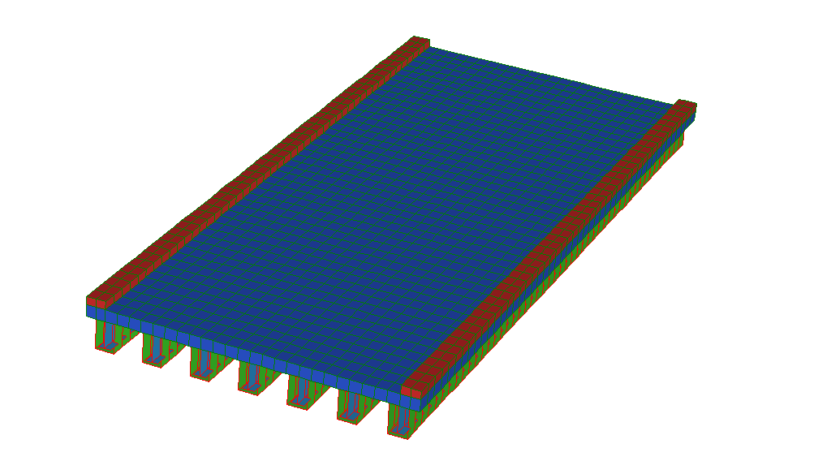

Y

X

Z

Figure 3. *A Priori* FE Model of single span of Bridge 138.

The initial model was rated for AASHTO Load and Resistance Factor Strength I and Service II limit states for an HL-93 truck. It was then calibrated to the natural frequencies and mode shapes developed through experimentation. A set of calibrated models were used to perform live load ratings. The six calibrated models with strong objective function and final parameter agreement were rated using the RAMPs software. In order to assure the most conservative load rating estimate while utilizing an updated FE model, stiffness and strength contributions from the concrete encasement and barriers were ignored in the ratings for the updated models.

## Appendix D-1 Bridge Description

Northampton County Bridge 138 is a simple span concrete-encased I-girder bridge and currently has a load posting of 20 tons (Figure 4 & Figure 5). The structure was built in 1946 and carries Club Road over Hokendauqua Creek in Northampton County, Pennsylvania. The bridge has an ADT of 150, a Deck Condition Rating of 6, a Superstructure Condition Rating of 5, and a Substructure Condition Rating of 5. The Sufficiency Rating is 36.4. The structure is not considered Structurally Deficient; however, it is Functionally Obsolete. Bridge 138 is 49 feet long, has a roadway width of 20 feet, an out-to-out width of 21.33 feet, and a clear distance between barriers of 17.92 feet. It carries Type-2 strong post guiderails over 16 inch wide, 7 inch high curbs. The structure consists of seven concrete-encased I-sections spaced at 3.33 feet, a 10 inch deck slab, and integral abutment bearings. The bridge has no skew or deck overlay.

No original plans exist for the bridge; however STV Inc. produced a Load Rating Summary performed in 2013 that details the structure cross-section. In their load rating, STV noted that Northampton County produced approximate beam dimensions after taking cores of the structure.

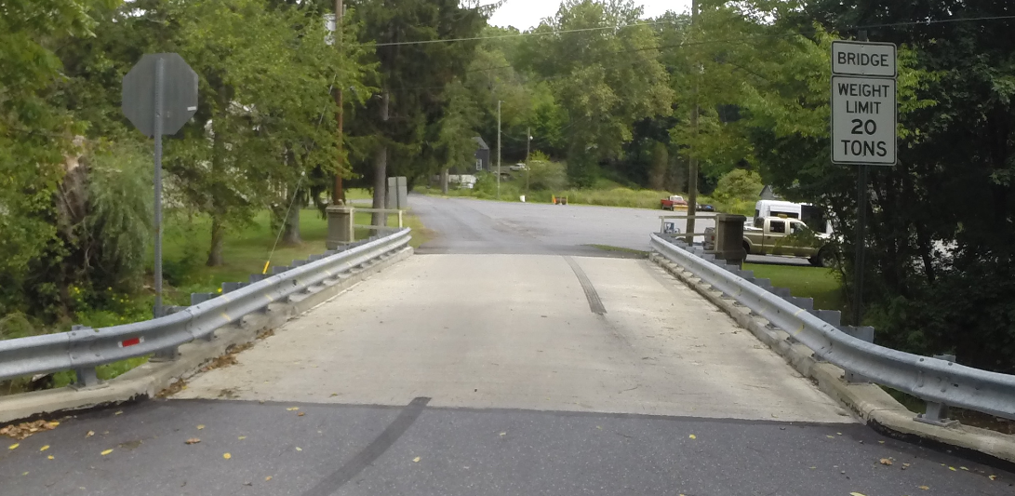

Figure 4. Northampton County Bridge 138

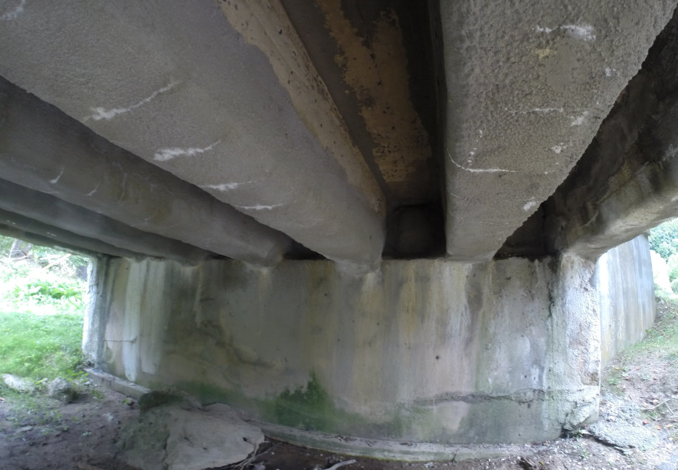

Figure 5. Underside view of the structure

## Appendix D-2 – Experimental Evaluation

Northampton County Bridge 138 was evaluated using vibration testing methods. The bridge was dynamically excited at several locations on the deck surface using a broad band impact force, and its corresponding vibration responses were measured using accelerometers that were also located on the deck. The combined input-output vibration measurements were subsequently analyzed to extract the dynamic properties of the structure which were then used to calibrate a finite element model of the bridge. Details of the experimental setup, the test execution and the data analysis methods employed for the bridge are provided in the following sections.

**Description of Test Equipment - THMPR™ System**

The Targeted Hits to Measure Performance Responses (THMPR™) system is a self-contained rapid modal testing trailer and streamlined data processing software which extracts modal parameters, such as frequencies and mode shapes, of a structure. The extracted modal parameters may then be used to determine anomalous behavior as well as provide experimental data for finite element model calibration. The system, shown in Figure 6, is comprised of a physical test device which utilizes a significantly reconfigured Falling Weight Deflectometer trailer with modifications to (1) provide a single, large (~30 kip) broadband impact source, and (2) collect the resulting free-decay response of the bridge’s surface in a spatially distributed manner (and in-turn be able to capture local mode shapes). The local sensor array is shown in Figure 7. The trailer is towed along the bridge deck and single-input-multiple-output (SIMO) impact testing is performed at targeted locations. The data is wirelessly acquired at each location and passed to semi-automated modal processing software which performs (1) data quality checks, (2) frequency response function development and (3) modal parameter estimation. The local mode shapes are then linearly combined into a final global modal parameter set utilizing selected stationary references previously secured along an available sidewalk and cabled to an independent, GPS synchronized data acquisition.



Figure 6. THMPR™ System - Primary Components



Figure 7. THMPR™ Local Sensor Array

### Instrumentation

The instrumentation plan is shown in Figure 8. A total of six stationary reference accelerometers (three in each shoulder) were temporarily attached to the bridge deck using glue adhesive at the quarter span, mid span, and three-quarter span locations. The reference accelerometers remained at the same locations on the deck throughout the vibration testing and were used to link together the vibrations measured by THMPR™’s local sensor array of six accelerometers (Figure 7). The reference accelerometers were cabled to a local GPS synchronized data acquisition system along the shoulder and out of the way of traffic.

A total of four impact locations were selected for the test: (1) at quarter span in the right lane, (2) at mid span in the right lane, (3) at three-quarter span in the left lane and (4) at mid span in the left lane. The impact locations were chosen so that the measured vibration responses would have a dense spatial resolution and to vary the spatial characteristics of the input excitation. The former consideration is important for resolving different mode shapes from the vibration measurements, while the latter is important for exciting different vibration modes.

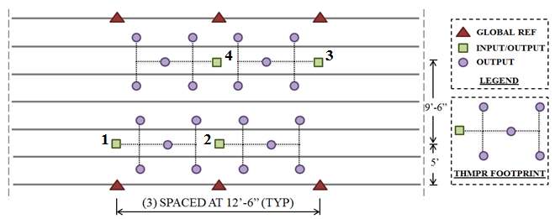

Figure 8. THMPR™ Instrumentation Plan for Bridge 138

### Test Execution

The THMPR™ system was roved onto the span at approximately 2:10 PM on September 8, 2014. THMPR™’s impact head was centered above a selected impact location on the deck and the GPS synchronized accelerometer array attached to THMPR™ was remotely deployed. This lowered the six accelerometer housings onto the bridge deck and compressed them against the surface (Figure 9). The impact force and bridge vibration measurements were recorded at a rate of 3,200 samples per second (Hz) in order to precisely define the shape of the impulse signal and for a duration of 10 seconds to ensure the complete capture of the structure’s post-impact free vibration decay response. A total of three separate impacts were recorded at each of the four locations for averaging and noise reduction purposes. The total time required to complete the vibration testing of the bridge was about 20 minutes with the final impact location being completed at 2:30 PM.

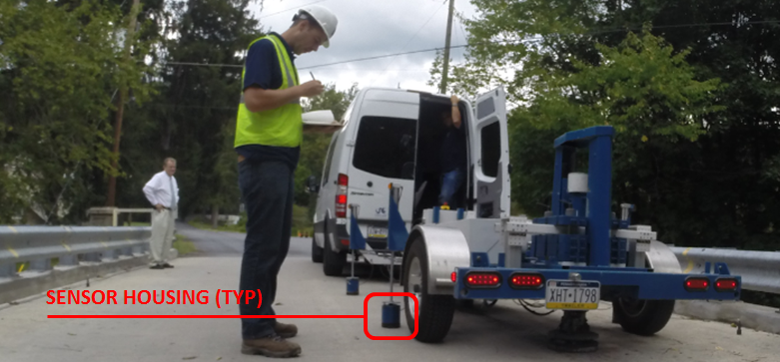

Figure 9. THMPR™ System Test Execution

### Data Quality

Typical impact forces of up to 25,000 lbs. were observed (Figure 10A) with an approximate usable frequency range of 0-60 Hz (Figure 10B). The impact forces produced by THMPR™ also resulted in bridge acceleration magnitudes of up to 2 g’s (Figure 11A). Frequency content of the structural response (Figure 11B) shows clearly defined, smooth peaks of resonance which indicates linearity, adequate frequency resolution, and good excitation of all fundamental modes of interest. The relatively large structural response and the acquisition of ten second time windows provided a frequency resolution of 0.09 Hz which resulted in good characterization of closely spaced modes.

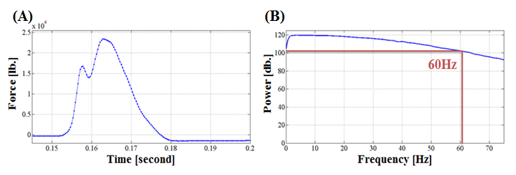

Figure 10. (A) Typical Force Time History & (B) Typical Force Frequency Content

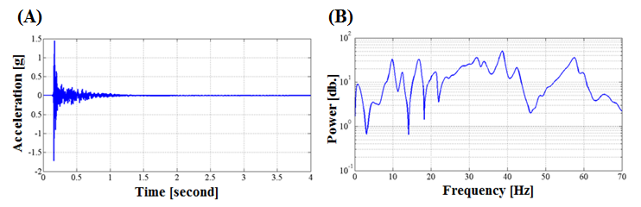

Figure 11. (A) Typical Response Time History & (B) Typical Response Frequency Content

### Modal Parameter Identification

The modal parameters for the structure were identified from the vibration measurements onsite after completion of the testing to provide immediate feedback on the data quality, structural response of the bridge, and operating condition of the test equipment to the on-site engineers. The modal parameters include the natural frequencies and the modal vectors (mode shapes) for each mode. These parameters are directly related to the in-situ mass and stiffness characteristics of the bridge, and are used for calibrating the FE model of the structure.

The modal parameter identification process starts with the computation of frequency response functions for each input-output measurement pair. A frequency response function is essentially the frequency domain transform of measured acceleration response at each sensor location divided by the measured impact force for each test location. The Complex Mode Indicator Function (CMIF) was then calculated for each test location (Figure 12) using the frequency response functions created in the previous step. The CMIF is computed by singular value decomposition of the matrix of frequency response functions for each test location. The largest singular values are plotted against frequency to create the CMIF plot. Each peak in the CMIF plot represents a location of a vibration mode for the structure and the amplitude of the singular value is directly related to the dominance of the corresponding modal vector at that test location. The singular values for each independent impact location are super imposed to compare areas of resonance and ultimately select global modal parameters. A total of eight global vibration modes (global poles) were identified from the CMIF plot as shown in Figure 12.

Additionally, dynamic characteristics are dependent on the mass and stiffness of the structure and careful consideration must be exercised during experimentation so as to not influence the measured dynamic properties of the test specimen. For example, adding a substantial amount of mass to a structure may artificially decrease the frequency of identified system poles and may also distort the extracted modal vectors. Due to the short span of the structure, the mass loading differed between each impact location and allowed for the mass loading effects of the THMPR™ system trailer and the tow vehicle to be investigated. The quarter span impact locations required the trailer and tow vehicle to be present on the superstructure while the mid span impact locations required only the trailer to be present on the superstructure. Despite these different mass loading configurations, consistent system poles are observed throughout each of the impact locations which indicates the additional mass of the THMPR™ system and towing vehicle had a negligible effect on the identified global poles and modal vectors of the structure.

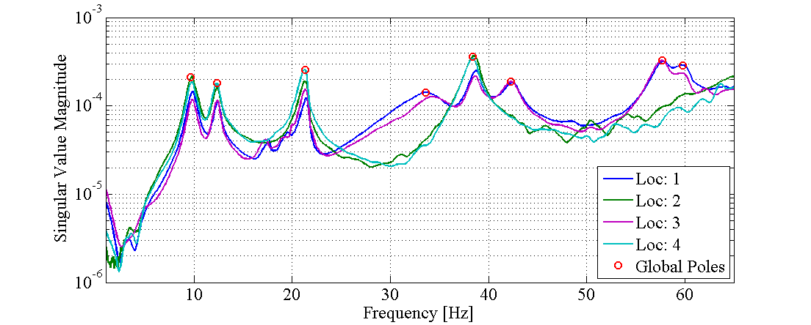

Figure 12. Complex Mode Indicator Function (CMIF)

Local mode shapes for each impact location were extracted at each global pole and combined into a global parameter set. Master mode shapes were selected for each mode based on the relative amplitude of the CMIF singular value for each impact location. The impact location associated with the largest CMIF amplitude for a specific vibration mode contains the highest signal to noise ratio and the corresponding mode shape was designated the master shape for that vibration mode. For each global pole, the modal amplitudes of the stationary references were compared between the local master mode shape and the remaining local mode shapes. A scaling coefficient was developed via a least squares approximation and used to linearly integrate the independent local mode shapes into the local master mode shape and form a global parameter set. Local mode shapes extracted from impact locations which coincided with a point of zero displacement (nodal point) for a particular mode were discarded and not included within the global modal parameter set. Additionally, a combination of the stationary references for each master local mode shape was chosen on an individual mode basis to avoid using reference sensors in locations of low modal amplitude for a particular mode. The first eight fundamental global mode shapes and corresponding frequencies occur within the frequency band of 0-60 Hz and are shown above in Figure 2 and Table 2, respectively. It should be noted that the interstitial areas between the discrete experimental degrees-of-freedom for the mode shapes shown in Figure 2 were interpolated using a fourth order equation to aid in the visualization of these shapes.

## Appendix D-3 – Model Updating

The *a priori* model was updated for each span using a multi-start method with 6 updating trials starting from different combinations of initial parameter values:

|  |  |  |  |  |
| --- | --- | --- | --- | --- |
|  | **Start Point** | | | |
| **Update** | *Deck* | *Encasement* | *Composite Action* | *R2* |
| *1* | Min | Min | Min | Min |
| *2* | Max | Min | Min | Min |
| *3* | Min | Max | Min | Min |
| *4* | Min | Min | Max | Min |
| *5* | Min | Min | Min | Max |
| *6* | Max | Max | Max | Max |

Presented in the table are the analytical mode shapes paired with the experimental results. Updated model modes shapes are typical for both spans of the structure. The *a priori* model from each span exhibited natural frequencies lower than that of the actual structure, indicating a lack of global stiffness. All updated models for both spans showed negligible differences in frequency from the experiment (+/- 5%). Mode shapes developed with THMPR™ were judges to be insufficient for model updating, therefore only frequency values were used in the objective function. Despite neglecting mode shapes for updating purposes, the updated models showed similar or better agreement with the experimental mode shapes than the *a priori* models. The updating results indicate that the updated models are accurate indicators of global stiffness.

Table 6. Experimental and Analytical Mode Shape Comparison

|  |  |
| --- | --- |
| ***Experimental Mode Shape*** | ***Paired Analytical Mode Shape*** |
| **Mode 1** | **Mode 1** |
| **Mode 2** | **Mode 2** |
| **Mode 3** | **Mode 3** |
| **Mode 4** | **Mode 5** |
| **Mode 5** | **Mode 7** |
| **Mode 6** | **Mode 8** |
| **Mode 7** | **Mode 10** |

Table 7. *A Priori* Final Dynamic Property Values

|  |  |  |  |  |
| --- | --- | --- | --- | --- |
| **MAC** | **Natural Frequency** | | | **Analytical Mode** |
| *Experimental [Hz]* | *Analytical [Hz]* | *% Difference* |
| 0.9900 | 9.67 | 3.47 | -64.07 | 1 |
| 0.9918 | 12.30 | 4.81 | -60.92 | 2 |
| 0.9544 | 21.29 | 12.03 | -43.49 | 3 |
| 0.8608 | 33.59 | 14.74 | -56.12 | 5 |
| 0.9180 | 38.38 | 27.03 | -29.58 | 9 |
| 0.9511 | 42.29 | 20.54 | -51.43 | 7 |
| 0.9021 | 57.71 | 33.16 | -42.55 | 12 |

Table 8. Updated Model 1 Dynamic Property Values

|  |  |  |  |  |
| --- | --- | --- | --- | --- |
| **MAC** | **Natural Frequency** | | | **Analytical Mode** |
| *Experimental [Hz]* | *Analytical [Hz]* | *% Difference* |
| 0.9910 | 9.67 | 10.02 | 3.65 | 1 |
| 0.9904 | 12.30 | 12.02 | -2.31 | 2 |
| 0.9433 | 21.29 | 21.20 | -0.40 | 3 |
| 0.8818 | 33.59 | 31.80 | -5.33 | 5 |
| 0.8815 | 38.38 | 39.88 | 3.90 | 7 |
| 0.9232 | 42.29 | 40.65 | -3.86 | 8 |
| 0.9536 | 57.71 | 56.11 | -2.78 | 10 |

Table 9. Updated Model 2 Dynamic Property Values

|  |  |  |  |  |
| --- | --- | --- | --- | --- |
| **MAC** | **Natural Frequency** | | | **Analytical Mode** |
| *Experimental [Hz]* | *Analytical [Hz]* | *% Difference* |
| 0.9909 | 9.67 | 10.03 | 3.78 | 1 |
| 0.9903 | 12.30 | 12.01 | -2.39 | 2 |
| 0.9432 | 21.29 | 21.19 | -0.48 | 3 |
| 0.8823 | 33.59 | 31.81 | -5.30 | 5 |
| 0.8819 | 38.38 | 39.86 | 3.87 | 7 |
| 0.9224 | 42.29 | 40.63 | -3.90 | 8 |
| 0.9538 | 57.71 | 56.10 | -2.80 | 10 |

Table 10. Updated Model 3 Dynamic Property Values

|  |  |  |  |  |
| --- | --- | --- | --- | --- |
| **MAC** | **Natural Frequency** | | | **Analytical Mode** |
| *Experimental [Hz]* | *Analytical [Hz]* | *% Difference* |
| 0.9866 | 9.67 | 10.46 | 8.21 | 1 |
| 0.9855 | 12.30 | 12.32 | 0.16 | 2 |
| 0.9410 | 21.29 | 20.76 | -2.49 | 3 |
| 0.8788 | 33.59 | 30.61 | -8.87 | 6 |
| 0.9040 | 38.38 | 38.89 | 1.34 | 8 |
| 0.9305 | 42.29 | 39.18 | -7.34 | 9 |
| 0.9412 | 57.71 | 55.49 | -3.86 | 11 |

Table 11. Updated Model 4 Dynamic Property Values

|  |  |  |  |  |
| --- | --- | --- | --- | --- |
| **MAC** | **Natural Frequency** | | | **Analytical Mode** |
| *Experimental [Hz]* | *Analytical [Hz]* | *% Difference* |
| 0.9910 | 9.67 | 10.02 | 3.67 | 1 |
| 0.9904 | 12.30 | 12.02 | -2.31 | 2 |
| 0.9433 | 21.29 | 21.21 | -0.39 | 3 |
| 0.8818 | 33.59 | 31.81 | -5.30 | 5 |
| 0.8814 | 38.38 | 39.88 | 3.91 | 7 |
| 0.9231 | 42.29 | 40.66 | -3.83 | 8 |
| 0.9536 | 57.71 | 56.12 | -2.77 | 10 |

Table 12. Updated Model 5 Dynamic Property Values

|  |  |  |  |  |
| --- | --- | --- | --- | --- |
| **MAC** | **Natural Frequency** | | | **Analytical Mode** |
| *Experimental [Hz]* | *Analytical [Hz]* | *% Difference* |
| 0.9911 | 9.67 | 10.02 | 3.65 | 1 |
| 0.9904 | 12.30 | 12.02 | -2.28 | 2 |
| 0.9433 | 21.29 | 21.21 | -0.37 | 3 |
| 0.8816 | 33.59 | 31.81 | -5.32 | 5 |
| 0.8814 | 38.38 | 39.88 | 3.91 | 7 |
| 0.9234 | 42.29 | 40.66 | -3.84 | 8 |
| 0.9536 | 57.71 | 56.11 | -2.77 | 10 |

## Appendix D-4 – Bridge Geometry and Material Properties

|  |  |  |  |  |
| --- | --- | --- | --- | --- |
|  | Int/Ext | | Notes |  |
| **Material Properties** | | |  |  |
| Steel Fy (psi) | 33000 | | Per AASHTO suggestion |  |
| Concrete f'c (psi) | 2500 | | Per AASHTO suggestion |  |
| Concrete Modulus (psi) | 2850000 | |  |  |
| Weight of Concrete (lb/ ft3) | 150 | |  |  |
| Weight of Steel (lb/ft3) | 490 | |  |  |
| **Beam Cross Section** | | |  |  |
| Deck Offset* (in.) | | -3.75 |  |  |
| Deck thickness (in.) | | 10 |  |  |
| Effective width (in.) | | 40/28 |  |  |
| Flange thickness (in.) | | 0.75 |  |  |
| Flange width (in.) | | 10.25 |  |  |
| Web thickness (in.) | | 0.75 |  |  |
| Web depth (in.) | | 24.75 |  |  |
| Encasement width (in.) | | 16 |  |  |
| Encasement depth (in.) | | 25 |  |  |
| Distance from Top of Slab to PNA (in.) | | 7.13057621 |  |  |
| Girder Moment of Inertia (in4) | | 3447.67676 |  |  |
| Composite Yield Moment (ln-in) | | 10478483.4 | / 10233321.6 |  |
| Composite Plastic Moment Capacity (lb-in) | | 16130845.6 | / 15330909.6 |  |
| **Bridge Cross Section** | | |  |  |
| Wearing Surface | 0 | |  |  |
| Out-to-Out Width (in.) | 256 | |  |  |
| Road Width (in.) | 224 | |  |  |
| Barrier Height (in.) | 25 | |  |  |
| Barrier width(in.) | 1 | |  |  |
| Curb Height (in.) | 7 | |  |  |
| Girder Spacing (in.) | 40 | |  |  |
| Number of Girders | 7 | |  |  |
| Number of Lanes | 2 | |  |  |
|  |  | |  |  |
| * Distance from top of flange to bottom of deck (values<0 indicate flange embedded in deck) | | | | |

## Appendix D-5 – LRFR Rating Details

Table 13: Updated Composite LRFR Rating Factors

|  |  |  |  |  |  |  |  |
| --- | --- | --- | --- | --- | --- | --- | --- |
| Girder # | 1 | 2 | 3 | 4 | 5 | 7 | 6 |
| **Limit State: Strength 1 Load Rating Factors** | | | | | | | |
| Inv. | 1.71 | 1.86 | 1.83 | 1.82 | 1.83 | 1.86 | 1.71 |
| Op. | 2.22 | 2.41 | 2.37 | 2.36 | 2.37 | 2.41 | 2.22 |
| **Limit State: Service 2 Load Rating Factors** | | | | | | | |
| Inv. | 1.70 | 1.59 | 1.57 | 1.58 | 1.57 | 1.59 | 1.70 |
| Op. | 2.21 | 2.06 | 2.04 | 2.06 | 2.04 | 2.06 | 2.21 |

Table 14: Updated Composite LRFR Demands

|  |  |  |  |  |  |  |
| --- | --- | --- | --- | --- | --- | --- |
| Girder # | 1 | 2 | 3 | 4 | 5 | 6 |
| **Moment Demands (lb-in)** | | | | | | |
| DL | 1547324 | 1835394 | 1912528 | 1912665 | 1912586 | 1835253 |
| SDL | 1618762 | 1564922 | 1530637 | 1518875 | 1530635 | 1564915 |
| LL | 3181304 | 3236382 | 3270755 | 3295248 | 3270751 | 3236369 |
| **Stress Demands (psi)** | | | | | | |
| DL | 6174.35 | 7281.84 | 7315.58 | 7293.05 | 7315.77 | 7281.39 |
| SDL | 4629.13 | 4481.49 | 4385.09 | 4349.21 | 4385.09 | 4481.47 |
| LL | 9305.2 | 9503.3 | 9621.9 | 9570.3 | 9621.9 | 9503.2 |

Table 15: Updated Composite LRFR Capacity

|  |  |
| --- | --- |
| Yield Stress Limit for Service State Capacity (psi): | 33000 |
| **Strength 1 Capacity of Exterior Girders** | |
| Stress Limit for Positive Moment Region (psi): | 33000 |
| Moment Limit for Positive Moment Region (lb-in): | 13498693 |
| **Strength 1 Capacity of Interior Girders** | |
| Stress Limit for Positive Moment Region (psi): | 30000 |
| Moment Limit for Positive Moment Region (lb-in): | 14782603 |

## Appendix D-6 – Distribution Factors

To provide a point of comparison between the FE model-based LRFR ratings and their single-line girder counterparts, the effective distribution factors were computed. These distribution factors represent the portion of a lane that must be assumed to be carried by interior/exterior girders within the single-line girder model to produce the same governing live load moments produced by the FE model. Table X provides a summary of the maximum interior and exterior effective distribution factors together with the distribution factors reference by the AASHTO LRFD Bridge Design Specifications.

Table 16: Comparison of effective distribution factors and AASHTO specified distribution factors

|  |  |  |  |  |
| --- | --- | --- | --- | --- |
|  | | **Live Load Moment Distribution Factors** | | |
|  | **Effective** | | **STV** | **AASHTO\*** |
| Interior | 0.2755 | | 0.238 | 0.12 |
| Exterior | 0.266 | | 0.303 | 0.12 |

* Small girder spacing dictates the AASHTO distribution factors be calculated using the lever rule.

# Appendix E – Bridge 200 Performance Evaluation and Load Rating Analysis

**Northampton County Bridge 200**

|  |  |
| --- | --- |
| **BMS No:** | 48 7413 0000 9200 |
| **Feature Carried:** | Columba Ave. |
| **Feature Intersected:** | Roseto Creek |
| **Structure Type:** | Concrete Encased Multi-Girder |
|  |  |
| **Test Date:** | 11/05/2014 |
| **Test Type:** | Dynamic Test |
| **Analysis and Rating Method:** | AASHTO LRFR |

Table 1. *A Priori* and Calibrated Model Load Ratings under AAHSTO HL-93 for Bridge 200.

|  |  |  |
| --- | --- | --- |
| **Bridge 200** | Span 1 | |
| Inventory | Operating |
| A-Priori | | |
| Strength I LRFR | 1.56 | 2.02 |
| Service II LRFR | 1.28 | 1.67 |
| Strength I LFR | 2.00 | 3.33 |
| Strength I ASR | 0.13 | 2.32 |
| Updated Composite | | |
| Strength I LRFR | 1.67 | 2.17 |
| Service II LRFR | 1.40 | 1.82 |
| Strength I LFR | 2.54 | 4.24 |
| Strength I ASR | 0.30 | 2.33 |
| Updated Non-Composite | | |
| Strength I LRFR | 1.04 | 1.35 |

No plans were provided for this structure. The geometry of the bridge and its components were investigated during the test. The geometry and material properties used are summarized in section 4 of this appendix. The structure was evaluated using forced vibration testing methods and the dynamic properties (natural frequencies and mode shapes) were extracted for finite element model calibration.

Strand7 FE Modelling Software was used in conjunction with computational software to perform a live load rating analysis for the bridge. An initial finite element (FE) model was created in Strand7 of the bridge. Conservative material properties, section properties, continuity conditions and boundary conditions were assumed for an initial model. A likely girder section was assumed for the structure using the girder sizing software developed by Drexel University. This girder section was designed using AASHTO *Standard Specifications* Allowable Stress Design for an H-15 truck. Girder placement within concrete encasement, girder sizing, and other design details were estimated by referring to bridge designs by the same engineering firm for Northampton Country during the same time period (mid 1920’s). The initial model was rated for AASHTO Load and Resistance Factor Strength I limit states for an HL-93 truck. Service II limit state was not considered due to lack of information about girder proportioning and inherent stability due to structurally active concrete encasement. The initial model was then calibrated to the natural frequencies and mode shapes developed through experimentation. A set of calibrated models were used to perform live load ratings for each span with and without enforcing composite action. Controlling ratings for the initial and calibrated models are summarized in the above table. Distribution factors are provided in section 6 of this appendix.

## Experimental Evaluation Summary

 Northampton County Bridge 200 was evaluated on November 5, 2014 using forced vibration testing methods and the dynamic properties (natural frequencies and mode shapes) were extracted for finite element model calibration.

Figure 1. THMPR™ System

A self-contained modal impact trailer equipped with a falling mass impact system and local sensor array was used to execute the vibration tests. The superstructure was excited via a 25 kip impulse force at multiple, spatially distributed locations which resulted in up to 3 g’s of bridge deck acceleration. Acceleration responses were measured via a local sensor array of six accelerometers and multiple spatially distributed stationary global references secured to the bridge deck via glue adhesive prior to testing. Local modal parameter estimation was performed utilizing the Complex Mode Indicator Function (CMIF) and integrated into a final global modal parameter set. Six natural frequencies and mode shapes were identified for span 1 and five natural frequencies and mode shapes were identified for span 2 in the frequency band of 0-65 Hz (Figure 2 & Table 2).

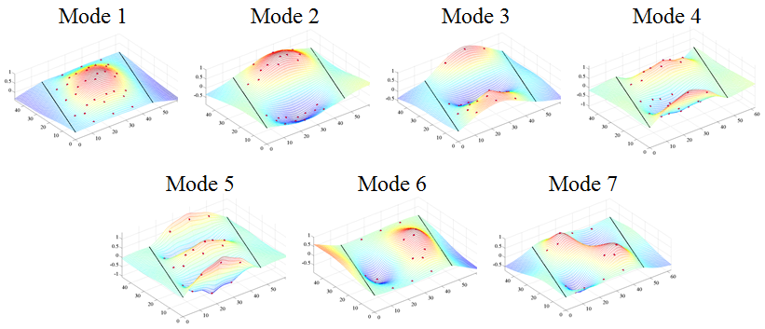

Figure 2. THMPR™ Results – Overview of Global Mode Shapes

Table 2. THMPR™ Results – Identified Natural Frequencies

|  |  |
| --- | --- |
| **Mode** | **Span 1**  **Frequency [Hz]** |
| 1 | 13.38 |
| 2 | 17.48 |
| 3 | 20.18 |
| 4 | 23.34 |
| 5 | 28.03 |
| 6 | 39.16 |
| 7 | 43.95 |

## Load Rating Analysis Summary

The structure was modeled using finite element analysis and computational software. An initial finite element (FE) model was created in Strand7 for both spans of Northampton County Bridge 041 using the RAMPS software package developed at Drexel University as part of a National Institute of Standards and Technology Innovation Program (NIST-TIP) and the National Cooperative Highway Research Program Project 12-103 (NCHRP 12-103).Conservative material properties, section properties, and boundary conditions were assumed for an initial model. The 3D geometric model (Figure 3) utilizes beam elements for the steel I-section and concrete encasement. Shell elements are used to model the deck and concrete curb. Rigid links as well as beam elements with variable stiffness are used to enforce compatibility of the displacements between the various structural elements.

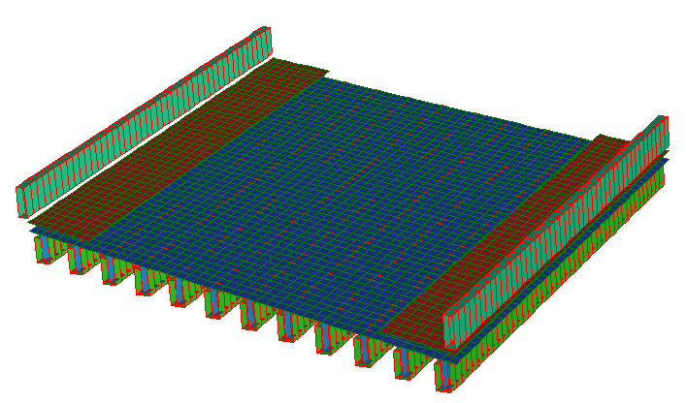

Y

X

Z

Figure 3. *A Priori* FE Model of single span of Bridge 041.

The initial model was rated for AASHTO Load and Resistance Factor Strength I and Service II limit states for an HL-93 truck. It was then calibrated to the natural frequencies and mode shapes developed through experimentation. A set of calibrated models were used to perform live load ratings. The six calibrated models with strong objective function and final parameter agreement were rated using the RAMPs software. In order to assure the most conservative load rating estimate while utilizing an updated FE model, stiffness and strength contributions from the concrete encasement and barriers were ignored in the ratings for the updated models.

## Appendix E-1 – Bridge Description

Northampton County Bridge 041 is a simply supported, concrete encased multi-girder structure with a 18⁰ skew. The steel encased within the concrete beams is of unknown type and design. The bridge carries Columbus Ave. in Roseto Borough over Roseto Creek, has an ADT of 400, and has a current posted weight limit of 30 tons. With a sufficiency rating of 81.1, the bridge is evaluated as “Not Structurally Deficient.” The span was measured with a length of 45’-10” and a roadway width of 32’-7”. The span carriers a 76” wide, 10” high sidewalk and 33” high, 10” wide concrete barriers (Figure 4). The overall deck thickness was measured to be approximately 9” with a 3” overlay. Each span has twelve (12) concrete encased beams with unknown reinforcement spaced at 4’-0” with overall dimensions of 27.5”x15”. Each girder has what appears to be 1-2” of shotcrete applied to the surface of the original concrete encasement at a time unknown to the engineer. The presence of shotcrete over the original concrete encasement may imply that some deterioration of the encasement was present.

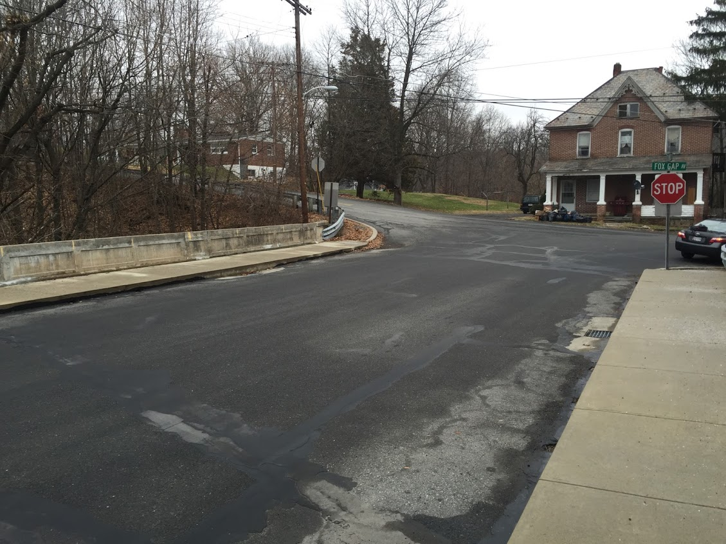

Figure 4. Northampton County Bridge 063

## Appendix E-2 – Experimental Evaluation

Northampton County Bridge 063 was evaluated using vibration testing methods. The bridge was dynamically excited at several locations on the deck surface using a broad band impact force, and its corresponding vibration responses were measured using accelerometers that were also located on the deck. The combined input-output vibration measurements were subsequently analyzed to extract the dynamic properties of the structure which were then used to calibrate a finite element model of the bridge. Details of the experimental setup, the test execution and the data analysis methods employed for the bridge are provided in the following sections.

### Description of Test Equipment - THMPR™ System

The Targeted Hits to Measure Performance Responses (THMPR™) system is a self-contained rapid modal testing trailer and streamlined data processing software which extracts modal parameters, such as frequencies and mode shapes, of a structure. The extracted modal parameters may then be used to determine anomalous behavior as well as provide experimental data for finite element model calibration. The system, shown in Figure 5, is comprised of a physical test device which utilizes a significantly reconfigured Falling Weight Deflectometer trailer with modifications to (1) provide a single, large (~30 kip) broadband impact source, and (2) collect the resulting free-decay response of the bridge’s surface in a spatially distributed manner (and in-turn be able to capture local mode shapes). The local sensor array is shown in Figure 6. The trailer is towed along the bridge deck and single-input-multiple-output (SIMO) impact testing is performed at targeted locations. The data is wirelessly acquired at each location and passed to semi-automated modal processing software which performs (1) data quality checks, (2) frequency response function development and (3) modal parameter estimation. The local mode shapes are then linearly combined into a final global modal parameter set utilizing selected stationary references previously secured along an available sidewalk and cabled to an independent, GPS synchronized data acquisition.



Figure 5. THMPR™ System - Primary Components



Figure 6. THMPR™ Local Sensor Array

### Instrumentation

The typical instrumentation plan for a single span is shown in Figure 7. A total of six stationary reference accelerometers were temporarily attached to the bridge deck using glue adhesive at the quarter span, mid span, and three-quarter span locations along each sidewalk. The reference accelerometers remained at the same locations on the deck throughout the vibration testing and were used to link together the vibrations measured by THMPR™’s local sensor array of six accelerometers (Figure 6). The reference accelerometers were cabled to GPS synchronized data acquisition systems along each shoulder and out of the way of traffic.

A total of nine impact locations were selected at the quarter span, mid span, and three-quarter span lengths along the right lane, left lane, and mid width lane of the superstructure. The impact locations were chosen so that the measured vibration responses would have a dense spatial resolution and to vary the spatial characteristics of the input excitation. The former consideration is important for resolving different mode shapes from the vibration measurements, while the latter is important for exciting different vibration modes. Note, only three of the six local output sensors were required for data analysis.

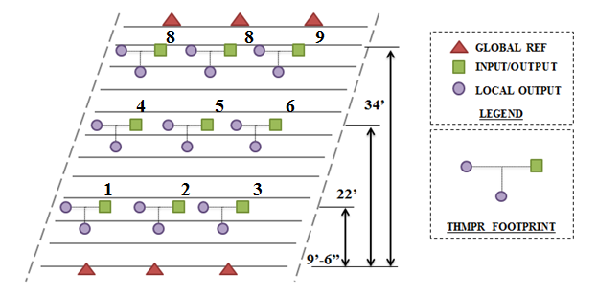

Figure 7. Typical Instrumentation Plan

### Test Execution

THMPR™ system testing was conducted on November 5, 2014. THMPR™’s impact head was centered above a selected impact location on the deck and the GPS synchronized accelerometer array attached to THMPR™ was remotely deployed. This lowered the six accelerometer housings onto the bridge deck and compressed them against the surface. The impact force and bridge vibration measurements were recorded at a rate of 3,200 samples per second (Hz) in order to precisely define the shape of the impulse signal and for a duration of 10 seconds to ensure the complete capture of the structure’s post-impact free vibration decay response. A total of three separate impacts were recorded for averaging and noise reduction purposes at each of the nine locations.

### Data Quality

Typical impact forces of up to 25,000 lbs. were observed (Figure 8A) with an approximate usable frequency range of 0-55 Hz (Figure 8B). The impact forces produced by THMPR™ also resulted in bridge acceleration magnitudes of up to 4 g’s (Figure 9A). Frequency content of the structural response (Figure 9B) shows clearly defined, smooth peaks of resonance which indicates linearity, adequate frequency resolution, and good excitation of all fundamental modes of interest. The relatively large structural response and the acquisition of ten second time windows provided a frequency resolution of 0.09 Hz which resulted in good characterization of closely spaced modes.

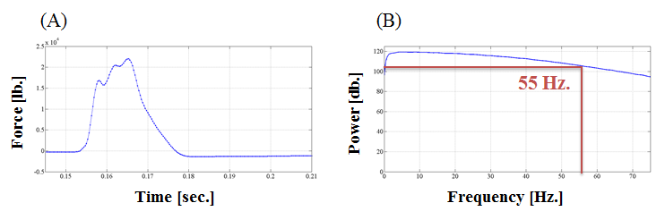

Figure 8. (A) Typical Force Time History & (B) Typical Force Frequency Content

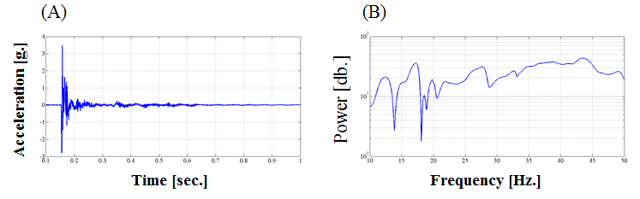

Figure 9. (A) Typical Response Time History & (B) Typical Response Frequency Content

### Modal Parameter Identification

The modal parameters for the structure were identified from the vibration measurements onsite after completion of the testing to provide immediate feedback on the data quality, structural response of the bridge, and operating condition of the test equipment to the on-site engineers. The modal parameters include the natural frequencies and the modal vectors (mode shapes) for each mode. These parameters are directly related to the in-situ mass and stiffness characteristics of the bridge, and are used for calibrating the FE model of the structure.

The modal parameter identification process starts with the computation of frequency response functions for each input-output measurement pair. A frequency response function is essentially the frequency domain transform of measured acceleration response at each sensor location divided by the measured impact force for each test location. The Complex Mode Indicator Function (CMIF) was then calculated for each test location (Figure 10) using the frequency response functions created in the previous step. The CMIF is computed by singular value decomposition of the matrix of frequency response functions for each test location. The largest singular values are plotted against frequency to create the CMIF plot. Each peak in the CMIF plot represents a location of a vibration mode for the structure and the amplitude of the singular value is directly related to the dominance of the corresponding modal vector at that test location. The singular values for each independent impact location are super imposed to compare areas of resonance and ultimately select global modal parameters. A total of seven global vibration modes (global poles) identified from the CMIF plots as shown in Figure 10.

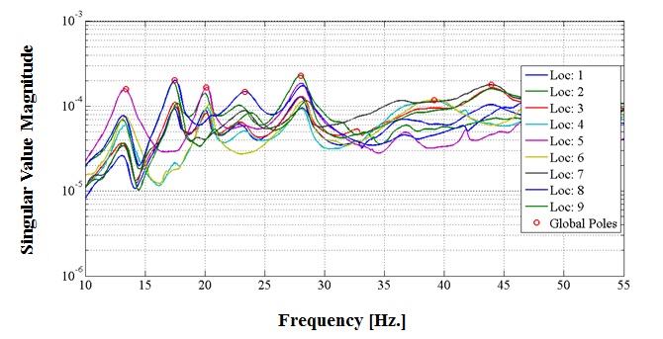

Figure 10. Span 1 – Complex Mode Indicator Function (CMIF)

Local mode shapes for each impact location were extracted at each global pole and combined into a global parameter set. Master mode shapes were selected for each mode based on the relative amplitude of the CMIF singular value for each impact location. The impact location associated with the largest CMIF amplitude for a specific vibration mode contains the highest signal to noise ratio and the corresponding mode shape was designated the master shape for that vibration mode. For each global pole, the modal amplitudes of the stationary references were compared between the local master mode shape and the remaining local mode shapes. A scaling coefficient was developed via a least squares approximation and used to linearly integrate the independent local mode shapes into the local master mode shape and form a global parameter set. Local mode shapes extracted from impact locations which coincided with a point of zero displacement (nodal point) for a particular mode were discarded and not included within the global modal parameter set. Additionally, a combination of the stationary references for each master local mode shape was chosen on an individual mode basis to avoid using reference sensors in locations of low modal amplitude for a particular mode. Global mode shapes and frequencies are shown in Figure 11 and Table 4, respectively. It should be noted that the interstitial areas between the discrete experimental degrees-of-freedom for the mode shapes were interpolated using a fourth order equation to aid in the visualization of these shapes.

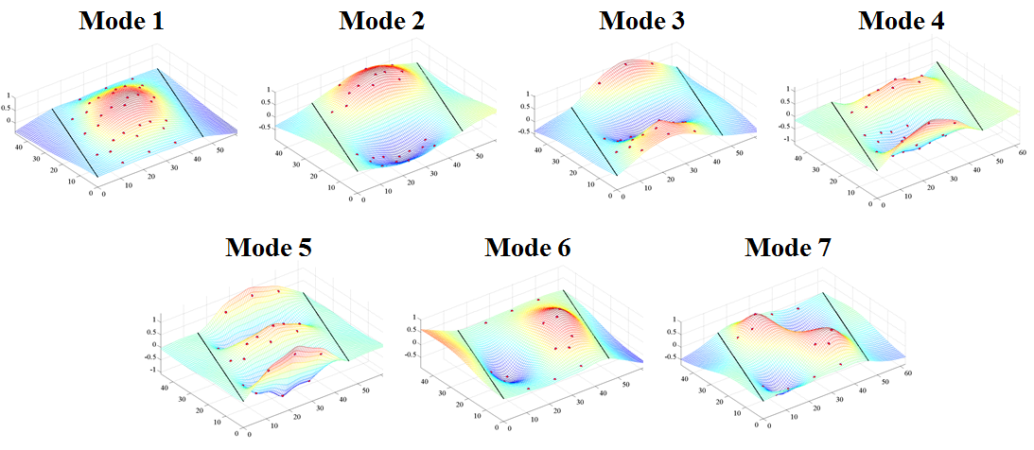

Figure 11. Span 1 – THMPR™ Results - Global Mode Shapes

Table 3. Span 1 – THMPR™ Results – Identified Natural Frequencies

|  |  |  |  |
| --- | --- | --- | --- |
| **Mode** | **Frequency [Hz]** | **Master**  **Location** | **Included Locations** |
| 1 | 13.38 | 6 | 1 2 3 4 5 6 7 8 9 |
| 2 | 17.48 | 8 | 1 2 3 7 8 9 |
| 3 | 20.18 | 5 | 1 2 3 4 5 6 |
| 4 | 23.34 | 8 | 1 2 3 4 5 7 8 9 |
| 5 | 28.03 | 2 | 1 2 3 4 5 6 7 8 9 |
| 6 | 39.16 | 6 | 3 4 6 |
| 7 | 43.95 | 7 | 1 3 7 9 |

## Appendix E-3 – Model Updating

The *a priori* model was updated for each span using a multi-start method with 8 updating trials starting from different combinations of initial parameter values:

|  |  |  |  |  |  |  |
| --- | --- | --- | --- | --- | --- | --- |
|  | **Start Point** | | | | | |
| **Update** | *Deck* | *Steel* | *Encasement* | *Sidewalks* | *Composite Action* | *R2* |
| *1* | Min | Min | Min | Min | Min | Min |
| *2* | Max | Min | Min | Min | Min | Min |
| *3* | Min | Max | Min | Min | Min | Min |
| *4* | Min | Min | Max | Min | Min | Min |
| *5* | Min | Min | Min | Max | Min | Min |
| *6* | Min | Min | Min | Min | Max | Min |
| *7* | Min | Min | Min | Min | Min | Max |
| *8* | Max | Max | Max | Max | Max | Max |

Presented in Table 5 are the analytical mode shapes paired with the experimental results. The *a priori* model exhibited natural frequencies lower than that of the actual structure, indicating a lack of global stiffness. The MAC comparison between experiment and *a priori* model indicate reasonable local stiffness distribution. All updated models showed moderate negative differences in frequency from the experiment for all but the first mode, indicating conservative values for global stiffness; meanwhile the MAC values remained high for every mode. The first mode of the updated models had positive frequency differences of about 15%, indicating a higher stiffness than the actual structure, however the MAC value remained high. This indicates a global excess of stiffness in the model, as opposed to a local error, such as boundary conditions. Because of this, the stiffness contribution of the concrete encasement will be neglected for load rating.

Table 4. Typical Mode Shapes

|  |  |  |  |
| --- | --- | --- | --- |
| A-Priori Shapes | Mode  Number | Typical Updated Model Shapes | Mode Number |
|  | **2** |  | **1** |
|  | **3** |  | **2** |
|  | **4** |  | **3** |
|  | **5** |  | **4** |
|  | **6** |  | **5** |
|  | **9** |  | **7** |
|  | **10** |  | **9** |

Table 5. Comparison of A-Priori and Experimental Mode Frequencies

|  |  |  |  |  |
| --- | --- | --- | --- | --- |
| **MAC** | **Natural Frequency** | | | **Analytical Mode** |
| *Experimental [Hz]* | *Analytical [Hz]* | *% Difference* |
| 0.9464 | 13.3789 | 7.5307 | -43.7121 | 2 |
| 0.9263 | 17.4805 | 8.8361 | -49.4517 | 3 |
| 0.7803 | 20.1172 | 11.9401 | -40.6473 | 4 |
| 0.9076 | 23.3398 | 15.038 | -35.5696 | 5 |
| 0.9384 | 28.0273 | 19.516 | -30.3681 | 6 |
| 0.9533 | 39.1602 | 25.9208 | -33.8082 | 9 |

Table 6. Comparison of Update 1 and Experimental Mode Frequencies

|  |  |  |  |  |
| --- | --- | --- | --- | --- |
| **MAC** | **Natural Frequency** | | | **Analytical Mode** |
| *Experimental [Hz]* | *Analytical [Hz]* | *% Difference* |
| 0.9777 | 13.3789 | 15.2794 | 14.2055 | 1 |
| 0.9464 | 17.4805 | 16.5053 | -5.5786 | 2 |
| 0.8647 | 20.1172 | 17.721 | -11.9111 | 3 |
| 0.9278 | 23.3398 | 20.5235 | -12.0668 | 4 |
| 0.9364 | 28.0273 | 25.1423 | -10.2935 | 5 |
| 0.9817 | 39.1602 | 39.1144 | -0.1169 | 7 |
| 0.9452 | 43.9453 | 41.8882 | -4.681 | 9 |

Table 7. Comparison of Update 2 and Experimental Mode Frequencies

|  |  |  |  |  |
| --- | --- | --- | --- | --- |
| **MAC** | **Natural Frequency** | | | **Analytical Mode** |
| *Experimental [Hz]* | *Analytical [Hz]* | *% Difference* |
| 0.9776 | 13.3789 | 15.3262 | 14.5548 | 1 |
| 0.9461 | 17.4805 | 16.5435 | -5.3601 | 2 |
| 0.8641 | 20.1172 | 17.7535 | -11.7494 | 3 |
| 0.9277 | 23.3398 | 20.5507 | -11.9503 | 4 |
| 0.9363 | 28.0273 | 25.1621 | -10.2229 | 5 |
| 0.9817 | 39.1602 | 39.2268 | 0.1701 | 7 |
| 0.945 | 43.9453 | 41.9869 | -4.4566 | 9 |

Table 8. Comparison of Update 3 and Experimental Mode Frequencies

|  |  |  |  |  |
| --- | --- | --- | --- | --- |
| **MAC** | **Natural Frequency** | | | **Analytical Mode** |
| *Experimental [Hz]* | *Analytical [Hz]* | *% Difference* |
| 0.9795 | 13.3789 | 15.4078 | 15.1651 | 1 |
| 0.9493 | 17.4805 | 16.6264 | -4.8857 | 2 |
| 0.8736 | 20.1172 | 17.7907 | -11.5649 | 3 |
| 0.9274 | 23.3398 | 20.4552 | -12.3594 | 4 |
| 0.9356 | 28.0273 | 24.8986 | -11.1631 | 5 |
| 0.9811 | 39.1602 | 39.3735 | 0.5447 | 7 |
| 0.9444 | 43.9453 | 42.0744 | -4.2575 | 9 |

Table 9. Comparison of Update 4 and Experimental Mode Frequencies

|  |  |  |  |  |
| --- | --- | --- | --- | --- |
| **MAC** | **Natural Frequency** | | | **Analytical Mode** |
| *Experimental [Hz]* | *Analytical [Hz]* | *% Difference* |
| 0.9779 | 13.3789 | 15.2985 | 14.3483 | 1 |
| 0.9467 | 17.4805 | 16.5225 | -5.48 | 2 |
| 0.8655 | 20.1172 | 17.7322 | -11.8555 | 3 |
| 0.9277 | 23.3398 | 20.52 | -12.0816 | 4 |
| 0.9363 | 28.0273 | 25.1198 | -10.3739 | 5 |
| 0.9816 | 39.1602 | 39.1556 | -0.0116 | 7 |
| 0.9451 | 43.9453 | 41.9202 | -4.6083 | 9 |

Table 10. Comparison of Update 5 and Experimental Mode Frequencies

|  |  |  |  |  |
| --- | --- | --- | --- | --- |
| **MAC** | **Natural Frequency** | | | **Analytical Mode** |
| *Experimental [Hz]* | *Analytical [Hz]* | *% Difference* |
| 0.9778 | 13.3789 | 15.2965 | 14.3333 | 1 |
| 0.9464 | 17.4805 | 16.5265 | -5.4576 | 2 |
| 0.8646 | 20.1172 | 17.7461 | -11.7865 | 3 |
| 0.9277 | 23.3398 | 20.5543 | -11.9347 | 4 |
| 0.9364 | 28.0273 | 25.1845 | -10.1431 | 5 |
| 0.9817 | 39.1602 | 39.1478 | -0.0316 | 7 |
| 0.9453 | 43.9453 | 41.9253 | -4.5967 | 9 |

Table 11. Comparison of Update 6 and Experimental Mode Frequencies

|  |  |  |  |  |
| --- | --- | --- | --- | --- |
| **MAC** | **Natural Frequency** | | | **Analytical Mode** |
| *Experimental [Hz]* | *Analytical [Hz]* | *% Difference* |
| 0.9792 | 13.3789 | 15.2934 | 14.3101 | 1 |
| 0.9488 | 17.4805 | 16.5281 | -5.4482 | 2 |
| 0.8715 | 20.1172 | 17.7188 | -11.922 | 3 |
| 0.9277 | 23.3398 | 20.4398 | -12.4253 | 4 |
| 0.936 | 28.0273 | 24.9561 | -10.958 | 5 |
| 0.9814 | 39.1602 | 39.1161 | -0.1125 | 7 |
| 0.9451 | 43.9453 | 41.8631 | -4.7383 | 9 |

Table 12. Comparison of Update 7 and Experimental Mode Frequencies

|  |  |  |  |  |
| --- | --- | --- | --- | --- |
| **MAC** | **Natural Frequency** | | | **Analytical Mode** |
| *Experimental [Hz]* | *Analytical [Hz]* | *% Difference* |
| 0.9777 | 13.3789 | 15.2828 | 14.2302 | 1 |
| 0.9464 | 17.4805 | 16.5074 | -5.5667 | 2 |
| 0.8646 | 20.1172 | 17.7223 | -11.9047 | 3 |
| 0.9278 | 23.3398 | 20.5241 | -12.0643 | 4 |
| 0.9364 | 28.0273 | 25.142 | -10.2949 | 5 |
| 0.9817 | 39.1602 | 39.1216 | -0.0986 | 7 |
| 0.9452 | 43.9453 | 41.8933 | -4.6695 | 9 |

Table 13. Comparison of Update 7 and Experimental Mode Frequencies

|  |  |  |  |  |
| --- | --- | --- | --- | --- |
| **MAC** | **Natural Frequency** | | | **Analytical Mode** |
| *Experimental [Hz]* | *Analytical [Hz]* | *% Difference* |
| 0.9776 | 13.3789 | 15.3489 | 14.7245 | 1 |
| 0.9461 | 17.4805 | 16.5633 | -5.2467 | 2 |
| 0.8645 | 20.1172 | 17.7683 | -11.6761 | 3 |
| 0.9276 | 23.3398 | 20.5548 | -11.9327 | 4 |
| 0.9363 | 28.0273 | 25.1525 | -10.2572 | 5 |
| 0.9816 | 39.1602 | 39.2788 | 0.3029 | 7 |
| 0.9449 | 43.9453 | 42.0301 | -4.3582 | 9 |

## Appendix E-4 – Bridge Geometry and Material Properties

|  |  |  |  |
| --- | --- | --- | --- |
|  | Int/Ext | Notes |  |
| **Material Properties** | |  |  |
| Steel Fy (psi) | 30000 | Per AASHTO suggestion |  |
| Concrete f'c (psi) | 2500 | Per AASHTO suggestion |  |
| Concrete Modulus (psi) | 2850000 |  |  |
| Weight of Concrete (lb/in3) | 0.08680556 |  |  |
| Weight of Steel (lb/ft3) | 490 |  |  |
| **Beam Cross Section** | |  |  |
| Deck Offset* (in.) | -4.7 |  |  |
| Deck thickness (in.) | 9 |  |  |
| Effective width (in.) | 48/41 |  |  |
| Flange thickness (in.) | 0.67 |  |  |
| Flange width (in.) | 10.5 |  |  |
| Web thickness (in.) | 0.52 |  |  |
| Web depth (in.) | 28.36 |  |  |
| Encasement width (in.) | 15 |  |  |
| Encasement depth (in.) | 27.5 |  |  |
| Distance from Top of Slab to PNA (in.) | 4.88185246 |  |  |
| Girder Moment of Inertia (in4) | 3953.28575 |  |  |
| Composite Yield Moment (lb-in) | 8956569.54 | / 8894809.19 |  |
| Composite Plastic Moment Capacity (lb-in) | 13657142.5 | / 13475899.6 |  |
| **Bridge Cross Section** | |  |  |
| Wearing Surface (in) | 3 |  |  |
| Out-to-Out Width (in.) | 562 |  |  |
| Road Width (in.) | 390 |  |  |
| Barrier Height (in.) | 33 |  |  |
| Barrier width(in.) | 10 |  |  |
| Curb Height (in.) | 10 |  |  |
| Girder Spacing (in.) | 48 |  |  |
| Number of Girders | 12 |  |  |
| Number of Lanes | 2 |  |  |
|  |  |  |  |
| * Distance from top of flange to bottom of deck (values<0 indicate flange embedded in deck) | | | |

## Appendix E-5 – LRFR Rating Details

Table 14: Updated Composite LRFR Rating Factors

|  |  |  |  |  |  |  |
| --- | --- | --- | --- | --- | --- | --- |
| Girder # | 1 | 2 | 3 | 4 | 5 | 6 |
| **Limit State: Strength 1 Load Rating Factors** | | | | | | |
| Inv. | 3.02 | 2.44 | 2.07 | 1.82 | 1.78 | 1.67 |
| Op. | 3.91 | 3.16 | 2.69 | 2.36 | 2.31 | 2.17 |
| **Limit State: Service 2 Load Rating Factors** | | | | | | |
| Inv. | 2.26 | 1.89 | 1.58 | 1.46 | 1.45 | 1.40 |
| Op. | 2.93 | 2.46 | 2.05 | 1.90 | 1.88 | 1.82 |
| Girder # | 7 | 8 | 9 | 10 | 11 | 12 |
| **Limit State: Strength 1 Load Rating Factors** | | | | | | |
| Inv. | 1.70 | 1.82 | 1.85 | 2.04 | 2.42 | 3.05 |
| Op. | 2.21 | 2.36 | 2.40 | 2.64 | 3.13 | 3.96 |
| **Limit State: Service 2 Load Rating Factors** | | | | | | |
| Inv. | 1.42 | 1.49 | 1.50 | 1.55 | 1.84 | 2.27 |
| Op. | 1.84 | 1.94 | 1.95 | 2.02 | 2.39 | 2.95 |

Table 15: Updated Composite LRFR Demands

|  |  |  |  |  |  |  |
| --- | --- | --- | --- | --- | --- | --- |
| Girder # | 1 | 2 | 3 | 4 | 5 | 6 |
| **Moment Demands (lb-in)** | | | | | | |
| DL | 1482110 | 1889276 | 1602895 | 1718860 | 1724992 | 1725591 |
| SDL | 2878212 | 2362799 | 1925134 | 1608119 | 1413525 | 1323241 |
|  | 110452 | 189407 | 269746 | 338326 | 385696 | 409173 |
| LL | 1402294 | 1789098 | 2324342 | 2687354 | 2801625 | 3009449 |
| **Stress Demands (psi)** | | | | | | |
| DL | 6429.54 | 7168.95 | 7019.07 | 6532.19 | 6486.02 | 6482.07 |
| SDL | 8838.53 | 7308.8 | 5971.51 | 4978.46 | 4355.61 | 4054.76 |
|  | 359.93 | 597.9 | 837.72 | 1040.37 | 1178.32 | 1244.08 |
| LL | 4388.3 | 5461.1 | 7165.2 | 8381.6 | 8752.3 | 9188.3 |
| Girder # | 7 | 8 | 9 | 10 | 11 | 12 |
| **Moment Demands (lb-in)** | | | | | | |
| DL | 1725888 | 1724434 | 1719427 | 1602636 | 1888988 | 1481916 |
| SDL | 1323250 | 1413539 | 1608062 | 1924954 | 2362615 | 2878014 |
|  | 409179 | 385712 | 338336 | 269742 | 189402 | 110439 |
| LL | 2954938 | 2742226 | 2650646 | 2366105 | 1807388 | 1384997 |
| **Stress Demands (psi)** | | | | | | |
| DL | 6483.13 | 6483.99 | 6534.12 | 7018.99 | 7158.69 | 6423.79 |
| SDL | 4057.14 | 4354.64 | 4967.85 | 5946.96 | 7283.07 | 8851 |
|  | 1247.17 | 1181.06 | 1042.3 | 838.66 | 598.04 | 361.19 |
| LL | 9084.7 | 8515.2 | 8167.6 | 7274.2 | 5623.8 | 4363.3 |

Table 16: Updated Composite LRFR Capacity

|  |  |
| --- | --- |
| Yield Stress Limit for Service State Capacity (psi): | 30000 |
| **Strength 1 Capacity of Exterior Girders** | |
| Stress Limit for Positive Moment Region (psi): | 30000 |
| Moment Limit for Positive Moment Region (lb-in): | 13018259 |
| **Strength 1 Capacity of Interior Girders** | |
| Stress Limit for Positive Moment Region (psi): | 30000 |
| Moment Limit for Positive Moment Region (lb-in): | 13240480 |

## Appendix E-5 – Distribution Factors

To provide a point of comparison between the FE model-based LRFR ratings and their single-line girder counterparts, the effective distribution factors were computed. These distribution factors represent the portion of a lane that must be assumed to be carried by interior/exterior girders within the single-line girder model to produce the same governing live load moments produced by the FE model. Table X provides a summary of the maximum interior and exterior effective distribution factors together with the distribution factors reference by the AASHTO LRFD Bridge Design Specifications.

Table17: Comparison of effective distribution factors and AASHTO specified distribution factors

|  |  |  |
| --- | --- | --- |
| **Live Load Moment Distribution Factors** | | |
|  | **Effective** | **AASHTO** |
| Interior | 0.2792 | 0.4062 |
| Exterior | 0.1301 | 0.4062 |